## **LEGAL INTELLECT: AN AI-POWERED LEGAL DOCUMENTATION ASSISTANT**

*Submitted for partial fulfillment of the requirements*

*for the award of*

**BACHELOR OF TECHNOLOGY**

**in**

**COMPUTER SCIENCE ENGINEERING –**

**ARTIFICIAL INTELLIGENCE & MACHINE LEARNING**

By

**Gundabattini Praneeth** - **20BQ1A4222**

**Chivukula Sai Madhava Sathvik** - **20BQ1A4212**

**Dusari Maheswari Preethi** - **20BQ1A4218**

**Gude Hemanth Sai** - **20BQ1A4221**

Under the guidance of

**Mrs. N. Nalini Krupa, Asst. Professor**



**DEPARTMENT OF COMPUTER SCIENCE ENGINEERING –**

**ARTIFICIAL INTELLIGENCE AND MACHINE LEARNING**

**VASIREDDY VENKATADRI INSTITUTE OF TECHNOLOGY**

Permanently Affiliated to JNTU Kakinada, Approved by AICTE

Accredited by NAAC with ‘A’ Grade, ISO 9001:2008 Certified

NAMBUR (V), PEDAKAKANI (M), GUNTUR – 522 508

Tel no: 0863-2118036, url: www.vvitguntur.com

April 2024



**CERTIFICATE**

This is to certify that the project entitled **“Legal Intellect”** is the bonafide work of Mr. G. Praneeth, Mr. Ch. Sathvik, Ms. D. Maheswari Preethi, Mr. G. Hemanth Sai, bearing Reg. No. **20BQ1A4222, 20BQ1A4212, 20BQ1A4218 and 20BQ1A4221** respectively who had carried out the project entitled **“Legal Intellect”** under our supervision.

#### Project Guide Head of the Department

(Mrs. N. Nalini Krupa**,** Assistant Professor) (Dr. K. Suresh Babu, Professor)

**Submitted for Viva-voce Examination held on**

**Internal Examiner External Examiner**

**DECLARATION**

We, Mr. G. Praneeth, Mr. Ch. Sathvik, Ms. D. Maheswari Preethi, Mr. G. Hemanth Sai, hereby declare that the Project Report entitled “**Legal Intellect: An Ai-Powered Legal Documentation Assistant**” done by us under the guidance of Mrs. N. Nalini Krupa, Assistant Professor, Computer Science Engineering - Artificial Intelligence & Machine Learning at Vasireddy Venkatadri Institute of Technology is submitted for partial fulfillment of the requirements for the award of Bachelor of Technology in Computer Science Engineering - Artificial Intelligence & Machine Learning. The results embodied in this report have not been submitted to any other University for the award of any degree.

DATE :

PLACE :

SIGNATURE OF THE CANDIDATES

Gundabattini Praneeth [20BQ1A4222]

Chivukula Sathvik [20BQ1A4212]

Dusari Maheswari Preethi [20BQ1A4218]

Gude Hemanth Sai [20BQ1A4221]

**ACKNOWLEDGMENT**

We take this opportunity to express my deepest gratitude and appreciation to all those people who made this project work easier with words of encouragement, motivation, discipline, and faith by offering different places to look to expand my ideas and helped me towards the successful completion of this project work.

First and foremost, we express my deep gratitude to **Sri. Vasireddy Vidya Sagar**, Chairman, Vasireddy Venkatadri Institute of Technology for providing necessary facilities throughout the B.Tech programme.

We express my sincere thanks to **Dr. Y. Mallikarjuna Reddy**, Principal, Vasireddy Venkatadri Institute of Technology for his constant support and cooperation throughout the B.Tech programme.

We express my sincere gratitude to **Dr. K. Suresh Babu**, Professor & HOD, Computer Science Engineering - Artificial Intelligence & Machine Learning, Vasireddy Venkatadri Institute of Technology for his constant encouragement, motivation and faith by offering different places to look to expand my ideas.

We would like to express my sincere gratefulness to our Guide **Mrs. N. Nalini Krupa,** Assistant Professor, Computer Science Engineering - Artificial Intelligence & Machine Learning department for her insightful advice, motivating suggestions, invaluable guidance, help and support in successful completion of this project.

We would like to express our sincere heartfelt thanks to our Project Coordinator **Mr. N. Balayesu,** Assistant professor, Computer Science Engineering - Artificial Intelligence & Machine Learning department for his valuable advices, motivating suggestions, moral support, help and coordination among us in successful completion of this project.

We would like to take this opportunity to express my thanks to the **Teaching and Non- Teaching** Staff in the Department of Computer Science Engineering - Artificial Intelligence & Machine Learning, VVIT for their invaluable help and support.

Name(s) of students

Gundabattini Praneeth [20BQ1A4222]

Chivukula Sathvik [20BQ1A4212]

Dusari Maheswari Preethi [20BQ1A4218]

Gude Hemanth Sai [20BQ1A4221]

#### **TABLE OF CONTENTS**

**Ch No Title Page No**

Table of Contents i

List of Figures iii

Nomenclature v

Abstract vi

1. INTRODUCTION 1
   1. Background and Need for Online Legal Service 1  
      and Documentation
   2. Problem Statement 1
   3. Objectives 2
2. REVIEW OF LITERATURE 5
3. METHODOLOGY 9
   1. Overview of the Proposed Solution 9
   2. Description of Technologies Used 11

3.2.1 Next.js 11

3.2.2 TRPC (Transport layer for RPC) 11

3.2.3 ChatGPT 12

3.2.4 FastAPI 13

3.2.5 LangChain 14

3.2.6 Kinde 15

3.2.7 Word Document Processing 16

3.2.8 UploadThing 17

3.2.9 Vector Database 18

1. IMPLEMENTATION 20
   1. General Architecture 20
   2. Design Phase 22

4.2.1 Use Case Diagram 22

4.2.2 Class Diagram 23

4.2.3 Sequence Diagram 24

4.2.4 Activity Diagram 25

* 1. Development Tools and Environment 26
  2. Sample Code 27

4.4.1 Vectorizing PDF Document 27

4.4.2 Chat with PDF Document 30

1. RESULTS 34
2. CONCLUSION AND FUTURE SCOPE 51
3. REFERENCES 53

APPENDIX 55  
Paper Publication Certificate 55  
Published Paper in Journal 59

# **LIST OF FIGURES**

|  |  |  |  |
| --- | --- | --- | --- |
| **Figure No** | **Figure Name** | **Page No** | |
| 4.1 | Secure Shell | 20 |
| 4.2 | Chat with PDF | 20 |
| 4.3 | Chat with LawQue | 21 |
| 4.4 | Chat with LawQue (Server architecture) | 21 |
| 4.5 | Use Case Diagram | 22 |
| 4.6 | Class Diagram | 23 |
| 4.7 | Sequence Diagram | 24 |
| 4.8 | Activity Diagram | 25 |
| 5.1 | Website Home Page-1 | 34 |
| 5.2 | Website Home Page-2 | 34 |
| 5.3 | Website Home Page-3 | 35 |
| 5.4 | Log-In Page | 35 |
| 5.5 | User Dashboard | 36 |
| 5.6 | LawQue Introduction Page-1 | 36 |
| 5.7 | LawQue Introduction Page-2 | 37 |
| 5.8  5.9 | LawQue Introduction Page-3  Chat with PDF – Drag and Drop Files | 37  38 |
| 5.10 | PDF Uploading | 38 |
| 5.11 | Chat with PDF | 39 |
| 5.12 | Bot Response – 1 | 39 |
| 5.13 | Bot Response – 2 | 40 |
| 5.14 | Personalized File Storage | 40 |
| 5.15 | Adding Title for Chat with LawQue | 41 |
| 5.16 | Chatting with LawQue – 1 | 41 |
| 5.17 | Chatting with LawQue – 2 | 42 |
| 5.18 | Chatting with LawQue – 3 | 42 |
| 5.19 | Chatting with LawQue – 4 | 43 |
| 5.20 | Scheduling Appointment with Legal Advisor | 43 |
| 5.21 | Scheduling Appointments Page | 44 |
| 5.22 | Schedule Appointment Page | 44 |
| 5.23 | Appointments Scheduled Page | 45 |
| 5.24 | Ask a Question | 45 |
| 5.25 | Ask a Question | 45 |
| 5.26 | Your Queries | 46 |
| 5.27 | Secure Shell – Secure Gateway | 47 |
| 5.28 | Secure Shell – Added Files | 47 |
| 5.29 | Secure Shell – Incorrect Password | 48 |
| 5.30 | Legal Documents | 48 |
| 5.31 | Business Services Agreement | 49 |
| **5.32** | Downloading Legal Document | 50 |

## **NOMENCLATURE**

|  |  |
| --- | --- |
| PDF  AWS | Portable Document Format  Amazon Web Services |
| S3 | Simple Storage Service |
| DB | Database |
| AI | Artificial Intelligence |
| API | Application Programming Interface |
| UI | User Interface |
| JWT | JSON Web Token |
| ORM | Object-Relational Mapping |
| DBMS | Database Management System |

## **ABSTRACT**

In today's fast-paced legal landscape, the efficient management of legal processes and communication channels is paramount. This document presents a comprehensive overview of our project, aimed at revolutionizing the legal industry through the integration of cutting-edge technologies and innovative solutions. Our platform offers a wide array of features and functionalities designed to streamline legal interactions, empower users with access to legal expertise, and enhance overall efficiency.At the core of our project lies a sophisticated chat-based system that enables seamless communication between users and legal advisors. Leveraging natural language processing (NLP) techniques and artificial intelligence (AI) algorithms, our chat interface facilitates intuitive and personalized interactions, allowing users to seek legal advice, clarify doubts, and receive guidance on various legal matters in real-time.Furthermore, our platform incorporates advanced document management capabilities, allowing users to securely upload, store, and manage legal documents. Through the integration of secure file storage systems and encryption protocols, we ensure the confidentiality and integrity of user data, providing peace of mind to our users.Additionally, our project includes features such as appointment scheduling, rating and review mechanisms, and personalized user profiles, enhancing the overall user experience and fostering trust and accountability within the legal community. By implementing robust authentication mechanisms and adhering to stringent security protocols, we prioritize the protection of user privacy and data security.Through extensive research, design, and development efforts, our project aims to revolutionize the legal industry by offering a comprehensive and user-centric platform that addresses the evolving needs of legal professionals and clients alike. With a focus on innovation, usability, and security, we strive to set new standards for legal technology and empower users to navigate the complexities of the legal landscape with confidence and ease.In conclusion, this document provides a detailed overview of our project, highlighting its objectives, key features, technological innovations, and potential impact on the legal industry. We believe that our project has the potential to transform the way legal services are delivered and accessed, ultimately empowering users and driving positive change within the legal community

**Keywords:** LegalTech, Chatbot, Natural Language Processing (NLP), Artificial Intelligence (AI), Document Management, Document Generation, Appointment Scheduling, Secure File Storage, User Authentication, Legal Advisory, Client-Provider Communication, Rating and Review, Data Privacy, Encryption, Accessibility, Legal Document Processing, Legal Expertise, User Authentication, AI bot (Law Que)

**CHAPTER 1**

**INTRODUCTION**

**1.1 Background and Need for Online Legal Services and Documentation**

The legal industry, like many others, is undergoing a profound transformation fueled by advancements in technology. Our project aims to leverage cutting-edge technologies to revolutionize the way legal services are accessed and delivered. With the increasing demand for convenient, efficient, and accessible legal assistance, our platform provides an innovative solution that bridges the gap between clients and legal service providers.At its core, our project introduces a comprehensive LegalTech ecosystem that encompasses various features and functionalities tailored to meet the diverse needs of users in the legal domain. The introduction of chatbot capabilities powered by state-of-the-art Natural Language Processing (NLP) algorithms enables seamless communication between users and the platform, facilitating instant access to legal information, advice, and assistance.

Moreover, our platform offers robust document management capabilities, allowing users to securely upload, store, and manage legal documents with ease. Through advanced encryption and secure file storage mechanisms, we prioritize data privacy and confidentiality, ensuring that sensitive information remains protected at all times.

Appointment scheduling functionalities streamline the process of booking consultations and meetings with legal service providers, enhancing efficiency and convenience for both clients and professionals. Additionally, features such as user authentication, rating, and review systems contribute to building trust and accountability within the platform, fostering a transparent and reliable environment for all stakeholders.

By integrating cutting-edge technologies such as Artificial Intelligence (AI), Machine Learning (ML), Natural Language Processing (NLP) and cloud-based solutions, our project aims to disrupt traditional models of legal service delivery and empower users with access to high-quality legal assistance anytime, anywhere. Through this introduction, we set the stage for exploring the various components and functionalities of our platform, highlighting its potential to reshape the legal landscape and improve access to justice for all.

**1.2 Problem Statement**

In the legal industry, traditional models of accessing legal services often present significant barriers and challenges for both clients and legal professionals. These challenges include limited accessibility to legal expertise, high costs associated with legal consultations and services, and inefficiencies in the process of scheduling appointments and managing legal documents. Moreover, there is often a lack of transparency and accountability in the legal service delivery process, leading to distrust and dissatisfaction among users.One of the primary problems addressed by our project is the accessibility of legal services. Many individuals and businesses face difficulties in accessing timely and affordable legal advice and assistance due to geographical constraints, financial limitations, or a lack of awareness about available legal resources. Additionally, the complexity of legal procedures and the intricacies of legal terminology can further deter individuals from seeking the assistance they need, especially in non-urgent or routine legal matters.Furthermore, the traditional approach to scheduling appointments with legal service providers is often cumbersome and time-consuming, requiring multiple phone calls or emails to coordinate meeting times. This inefficiency not only inconveniences clients but also poses challenges for legal professionals in managing their schedules effectively. Additionally, the manual process of managing legal documents, such as contracts, agreements, and court filings, can be prone to errors and inconsistencies, leading to potential legal disputes or compliance issues.Another significant problem in the legal industry is the lack of transparency and accountability in the selection and evaluation of legal service providers. Clients often struggle to assess the qualifications, expertise, and reputation of potential legal professionals, making it challenging to make informed decisions about whom to engage for their legal needs. Moreover, the absence of standardized rating and review systems for legal services can lead to disparities in service quality and client satisfaction across different providers.Overall, the complex and fragmented nature of the legal industry presents numerous challenges for both clients and legal professionals. Our project seeks to address these challenges by leveraging technology to enhance the accessibility, efficiency, and transparency of legal service delivery, ultimately empowering individuals and businesses to navigate the legal landscape more effectively and affordably. Through innovative features and functionalities, we aim to democratize access to justice and improve the overall user experience in the legal domain.

**1.3 Objectives**

To drive innovation in the legal industry and address existing challenges, our project is committed to achieving several key objectives. The objectives of our project encompass a broad range of goals aimed at addressing the challenges and inefficiencies prevalent in the legal industry while leveraging technology to enhance the accessibility, efficiency, and transparency of legal service delivery. These objectives are meticulously crafted to ensure that our project meets the diverse needs of clients and legal professionals alike, ultimately empowering users to navigate the legal landscape more effectively and affordably.

Below are detailed objectives:

**Improve Accessibility:** One of the primary objectives of our project is to enhance accessibility to legal services for individuals and businesses, regardless of their geographical location, financial constraints, or familiarity with legal processes. By leveraging digital platforms and online tools, we aim to bridge the gap between clients and legal professionals, making legal expertise more readily available and easily accessible.

**Streamline Appointment Scheduling:** We endeavor to streamline the process of scheduling appointments with legal service providers by implementing efficient and user-friendly scheduling systems. Through automated appointment booking functionalities and real-time availability updates, we aim to simplify the scheduling process for both clients and legal professionals, reducing the time and effort required to coordinate meetings.**Facilitate Document Management:** Another key objective is to facilitate the management of legal documents, such as contracts, agreements, and court filings, through digital document management solutions. By providing secure and centralized repositories for storing, organizing, and accessing legal documents, we aim to improve the efficiency and accuracy of document handling processes, minimizing the risk of errors and compliance issues.**Enhance Communication and Collaboration:** Our project aims to enhance communication and collaboration between clients and legal service providers through integrated messaging and collaboration tools. By enabling seamless communication channels and document sharing capabilities, we seek to facilitate transparent and effective communication between parties, fostering greater trust and collaboration throughout the legal service delivery process.**Implement Intelligent Matching:** We aspire to implement intelligent matching algorithms that leverage machine learning and data analytics techniques to match clients with suitable legal service providers based on their specific needs, preferences, and expertise. By analyzing client requirements and provider profiles, we aim to facilitate more accurate and personalized matches, enhancing the overall user experience and satisfaction.**Ensure Data Security and Privacy:** One of our paramount objectives is to ensure the security and privacy of user data throughout the legal service delivery process. By implementing robust data encryption, access controls, and privacy safeguards, we aim to protect sensitive information and uphold the highest standards of data security and confidentiality, earning the trust and confidence of our users.

**Incorporate User Feedback and Iterative Improvement:** Our project emphasizes the importance of incorporating user feedback and iterative improvement processes to continuously enhance the platform's features, functionalities, and user experience. By actively soliciting user feedback, analyzing usage metrics, and implementing iterative updates and enhancements, we aim to adapt to evolving user needs and preferences, ensuring the platform remains relevant and effective over time.In summary, our project's objectives are centered around leveraging technology to address the existing challenges and inefficiencies in the legal industry, with a strong focus on improving accessibility, efficiency, transparency, and user experience. By pursuing these objectives diligently, we aim to revolutionize the way legal services are accessed, delivered, and experienced, ultimately empowering individuals and businesses to navigate the legal landscape with confidence and ease.

**CHAPTER 2**

**REVIEW OF LITERATURE**

**1. Topsakal and Akinci (2023):**

This primer provides a detailed exploration of LangChain's capabilities in developing Large Language Model (LLM) applications. It covers various aspects of LLM development, including data preprocessing, model training, and deployment strategies. The authors emphasize the importance of speed and efficiency in application development, highlighting LangChain's role in accelerating the process. They also discuss best practices for optimizing LLM performance and ensuring robustness in real-world applications.

**2. Nigam et al. (2023):**

This study investigates the efficacy of modern AI models in addressing legal question-answering challenges within the Indian context. It examines the unique complexities of Indian legal systems and explores how AI technologies can enhance legal research and practice. The authors analyze the strengths and limitations of existing AI models in handling Indian legal queries, shedding light on areas for improvement and future research directions. They also discuss the potential impact of AI on legal education and access to justice in India.

**3. Harrington (2023):**

Harrington's work offers a nuanced perspective on the integration of Large Language Models (LLMs) in legal research. As a Law & Technology Librarian, he explores the practical implications of LLM adoption for legal professionals and researchers. Harrington examines the evolving role of librarians in supporting AI-driven legal research and highlights the ethical considerations associated with LLM usage. He also provides insights into potential challenges and opportunities in leveraging LLMs for legal information retrieval and analysis.

**4. Linna Jr (2022):**

Linna Jr's primer provides attorneys with a comprehensive overview of Machine Learning and Natural Language Processing (NLP) technologies. It explains fundamental concepts and techniques in ML and NLP, tailored to the legal domain. The author emphasizes the ethical implications of AI integration in legal practice and offers practical guidance for attorneys navigating the intersection of law and technology. Linna Jr also discusses emerging trends in legal tech and the importance of ongoing education for legal professionals.

**5. Corrales et al. (2019):**

This research explores the transformative potential of blockchain technology in the legal domain. The authors examine the applications of blockchain in smart contracts, digital identity management, and dispute resolution. They discuss the benefits of blockchain for enhancing transparency, security, and efficiency in legal processes, while also addressing potential challenges and regulatory considerations. Corrales et al. provide insights into the future of blockchain in legal tech and its implications for legal practitioners and policymakers.

**6. Chalkidis et al. (2021):**

Chalkidis et al. present an innovative approach to contract analysis using Natural Language Processing (NLP) techniques. They discuss the challenges of extracting contract elements from legal documents and propose advanced NLP models for automated contract analysis. The authors evaluate the performance of their approach on diverse datasets and highlight its potential for streamlining contract management processes. They also discuss the implications of NLP-based contract analysis for legal practitioners and organizations.

**7. Zhong et al. (2020):**

This comprehensive overview examines the various ways in which Natural Language Processing (NLP) technologies benefit the legal system. The authors explore applications of NLP in legal document analysis, information retrieval, and legal decision-making. They discuss the potential of NLP to automate routine legal tasks, improve access to legal information, and enhance legal research efficiency. Zhong et al. also highlight the challenges and limitations of current NLP technologies in the legal domain, paving the way for future research and development.

**8. Gosteva and Pristavka (2022):**

Gosteva and Pristavka offer a detailed survey of legal document generation with Large Language Models (LLMs). They discuss the capabilities of LLMs in generating contextually relevant legal documents, such as contracts, agreements, and court pleadings. The authors analyze the performance of LLM-based document generation systems and explore potential use cases in legal practice. They also address challenges related to model accuracy, data privacy, and regulatory compliance, providing insights into the future of LLM-powered document automation.

**9. Katsh and Rabinovich-Einy (2021):**

Katsh and Rabinovich-Einy examine the impact of technology on dispute resolution processes, focusing on the emergence of digital justice and online dispute resolution (ODR) platforms. They discuss the benefits of digital justice for improving access to justice, reducing case backlogs, and enhancing dispute resolution efficiency. The authors also address concerns related to privacy, security, and procedural fairness in digital dispute resolution, offering recommendations for policymakers and legal practitioners.

**10. Lawtech.Asia (2022):**

This research report provides a comprehensive overview of the legal AI landscape in Asia, analyzing trends, challenges, and opportunities in the adoption of AI technologies in the legal industry. The authors examine key drivers of legal tech innovation in Asia, such as regulatory changes, market demand, and technological advancements. They also discuss the role of government initiatives, industry collaborations, and educational programs in promoting legal tech adoption across the region. Lawtech.Asia offers insights

into the future direction of legal tech in Asia and its implications for legal professionals and organizations.

**11. Devlin et al. (2019):**

Devlin et al. introduce BERT, a state-of-the-art language model pre-training technique, revolutionizing natural language understanding tasks. They discuss the architecture and training methodology of BERT, highlighting its effectiveness in capturing contextual information and improving the performance of downstream NLP tasks. The authors provide examples of BERT applications in various domains, including legal question-answering, document classification, and sentiment analysis, demonstrating its versatility and scalability.

**12. Brown et al. (2020):**

Brown et al. propose a few-shot learning approach for language models, enabling them to adapt to new tasks with minimal training data. They discuss the challenges of fine-tuning pre-trained models for specific tasks and introduce a novel training objective called "prompt engineering." The authors demonstrate the effectiveness of few-shot learning in various NLP tasks, including text classification, language modeling, and question-answering, highlighting its potential for rapid model adaptation and deployment in real-world applications.

**13. Raffel et al. (2019):**

Raffel et al. explore the limits of transfer learning with a unified text-to-text transformer architecture, showcasing its effectiveness in various NLP tasks. They discuss the architecture and training methodology of the text-to-text transformer, highlighting its ability to handle diverse input-output modalities. The authors provide empirical results on benchmark datasets, demonstrating the superior performance of the text-to-text transformer compared to traditional sequence-to-sequence models. They also discuss future research directions and potential applications of the text-to-text transformer in legal NLP tasks.

**14. Rush (2018):**

Rush presents the annotated encoder-decoder architecture with attention mechanisms, laying the foundation for transformer-based models in sequence-to-sequence learning tasks. He discusses the architecture, training methodology, and applications of the annotated encoder-decoder model in various NLP tasks, such as machine translation, text summarization, and document generation. Rush highlights the importance of attention mechanisms in capturing long-range dependencies and improving model performance on complex NLP tasks.

**15. Wolf et al. (2019):**

Wolf et al. introduce HuggingFace's Transformers, a state-of-the-art NLP library, enabling researchers and practitioners to leverage pre-trained transformer models for various NLP tasks. They discuss the architecture, capabilities, and usage of Transformers, highlighting its extensive model zoo and user-friendly API. The authors provide examples of Transformer-based applications in text classification, sequence labeling, and language generation, demonstrating its versatility and scalability.

**16. Pappu et al. (2016):**

Pappu et al. propose a legal domain-specific question-answering system using a hybrid approach, combining rule-based methods and machine learning techniques. They discuss the challenges of legal question-answering and introduce a hybrid architecture that leverages structured legal knowledge and corpus-based learning. The authors evaluate the performance of their system on legal question-answering datasets, demonstrating its effectiveness in retrieving accurate and relevant legal information.

**17. Liakata et al. (2013):**

Liakata et al. discuss the construction of a legal knowledge base for question-answering in the legal domain, leveraging annotated legal texts and ontologies. They describe the process of knowledge acquisition, representation, and querying in the legal knowledge base, highlighting the importance of domain-specific ontologies and semantic annotations. The authors demonstrate the utility of the knowledge base in legal question-answering tasks, showcasing its ability to retrieve relevant legal information and provide accurate responses to user queries.

**18. Thorne et al. (2018):**

Thorne et al. explore the generation of sentences from disentangled syntactic and semantic representations, offering insights into advanced language generation techniques. They discuss the architecture and training methodology of the disentangled sentence generator, highlighting its ability to capture fine-grained syntactic and semantic structures. The authors provide empirical results on benchmark datasets, demonstrating the effectiveness of the disentangled generator in generating fluent and contextually relevant sentences. They also discuss potential applications of the disentangled generator in legal text generation tasks, such as contract drafting and legal document summarization.

**CHAPTER 3**

**METHODOLOGY**

**3.1 Overview of the Proposed Solution**

Our project adopts a systematic approach to design and implement a sophisticated legal support platform that caters to diverse user needs and ensures optimal performance and reliability. The methodology encompasses several key phases, each meticulously planned and executed to achieve the project's objectives effectively.**Requirement Analysis:**Conduct thorough research and analysis to understand user requirements, industry trends, and market demands.Gather feedback from potential users and stakeholders to identify key pain points and areas for improvement in existing legal support systems.Define clear and comprehensive requirements based on the insights gained from research and user feedback, ensuring alignment with project goals and objectives.

**System Architecture Design:**Develop a modular and scalable architecture that can accommodate current and future feature expansions and user growth.Prioritize modularity, scalability, and optimal user experience in the architectural design to ensure flexibility and adaptability.Utilize industry best practices and design principles to create a robust and efficient system architecture that meets the project's technical requirements and performance goals.

**Chat Functionalities:**Implement a range of chat functionalities, including Chat with PDF, Chat with AI Bot (LawQue), and Chat with Legal Advisor, to facilitate seamless communication and collaboration between users and legal professionals.Utilize advanced natural language processing (NLP) techniques and machine learning algorithms to enable intelligent conversation and provide relevant legal insights and assistance.Integrate third-party tools and APIs, such as LangChain and ChatGPT, to enhance the chat functionalities and enrich the user experience.

**Document Management:**Design and implement a comprehensive document management system that allows users to efficiently prepare, store, and manage legal documents.Utilize a FastAPI-backed Python backend to handle document processing and storage, ensuring speed, reliability, and security.Incorporate features like Legal Document Preparation and Legal Document Assistance to guide users through the document creation process and provide contextual assistance as needed.

**User Interactions:**Develop interactive features, such as Q&A Regarding Legal Issues and Appointment Scheduling, to facilitate user engagement and streamline the legal consultation process.Design intuitive user interfaces that are easy to navigate and use, ensuring a seamless and enjoyable experience for both users and legal professionals.Implement backend logic and algorithms to handle user requests and actions effectively, providing timely and accurate responses to queries and requests.

**File Management:**Establish a secure and personalized file storage system that allows users to store and access their legal documents securely.Implement robust security measures, including encryption and access controls, to protect sensitive information and ensure data privacy and confidentiality.Integrate features like Secure Shell for Files to further enhance the security of file interactions and prevent unauthorized access or data breaches.

**User Feedback and Accountability:**Incorporate mechanisms for collecting user feedback and ratings to gauge user satisfaction and identify areas for improvement.Implement features like Rating & Review to allow users to provide feedback on legal services and share their experiences with others.Use analytics and reporting tools to analyze user feedback and monitor platform performance, ensuring accountability and continuous improvement.

**User Authentication:**Implement secure user authentication mechanisms, including options like social login and passwordless access, to ensure user accounts are protected from unauthorized access.Utilize third-party authentication services, such as Kinde, to streamline the authentication process and enhance user convenience and security.

**Modular and Scalable Architecture:**Design the platform's architecture to be modular and extensible, allowing for easy integration of new features and services.Utilize microservices architecture and containerization techniques to ensure scalability and flexibility, enabling the platform to handle increasing user loads and resource demands.Implement cloud-native solutions and infrastructure as code (IaC) practices to automate deployment and management tasks and optimize resource utilization and cost efficiency.

**Iterative Development and Testing:**Adopt an agile development methodology to iteratively design, develop, and test platform features and functionalities.Conduct thorough testing, including unit testing, integration testing, and end-to-end testing, to identify and address defects and ensure the platform's reliability and stability.Use continuous integration and continuous deployment (CI/CD) pipelines to automate the build, test, and deployment processes and accelerate the delivery of new features and updates to users.

In conclusion, the methodologies employed in our project were instrumental in delivering a sophisticated and user-friendly legal support platform that meets the diverse needs of users and legal professionals. Moving forward, we remain committed to iterative development and continuous improvement, ensuring that our platform evolves to meet the changing needs of our users and the legal industry.

**3.2 Description of Technologies Used**

**3.2.1 Next.js:**

Next.js is a popular open-source React framework that is used for building modern web applications. It provides a variety of features and benefits that make it a preferred choice for developers. Here's a detailed overview of how Next.js is used in our project

**1.Server-Side Rendering (SSR):** Next.js enables server-side rendering out of the box, allowing you to pre-render pages on the server and send HTML to the client. This improves performance and SEO as search engines can easily crawl the content.**2.Static Site Generation (SSG):** It supports static site generation, where pages can be pre-built at build time. This results in faster page loads and improved user experience.**3.Dynamic Routing**: Next.js offers dynamic routing capabilities, allowing you to create dynamic routes based on parameters. This is useful for building dynamic web applications with personalized content.**4.File-Based Routing:** Routing in Next.js is based on the file system, making it intuitive and easy to manage. Each page corresponds to a file in the project directory, simplifying navigation and organization.**5.API Routes:** Next.js allows you to create API routes within our application, making it easy to handle server-side logic and data fetching. This enables seamless integration with backend services and databases.**6.Built-in CSS Support:** It provides built-in support for CSS modules, CSS-in-JS libraries like styled-components, and global CSS files. This makes styling components straightforward and flexible.**7.Optimized Performance:** Next.js optimizes performance by automatically code splitting, prefetching, and lazy loading components. This ensures that only the necessary code is loaded, reducing initial page load times.**8.TypeScript Support:** Next.js has excellent support for TypeScript, allowing you to write type-safe code and catch errors early in the development process.**9.Developer Experience:** It offers a great developer experience with features like hot module replacement (HMR), fast refresh, and built-in support for development tools like ESLint and Prettier.**10.Production-Ready Deployment:** Next.js provides optimized build configurations for production deployments, making it easy to deploy our application to platforms like Vercel, AWS, or Netlify.

Overall, Next.js is a powerful framework for building modern, performant, and scalable web applications with React, offering a wide range of features and benefits for developers.

**3.2.2 TRPC (Transport layer for RPC):**

TRPC (Transport Layer for RPC) is a modern framework for building efficient and type-safe API servers in TypeScript. It simplifies the development of RPC (Remote Procedure Call) services by providing a streamlined approach to defining APIs, handling requests, and managing data flows. Here's a detailed overview of how TRPC (Transport Layer for RPC) is used in our project:

**1.Type-Safe APIs:** TRPC allows you to define APIs using TypeScript types, ensuring type safety and validation at compile time. This reduces the likelihood of runtime errors and improves code quality and maintainability.**2.Declarative API Definition:** With TRPC, you can define our API endpoints using a declarative syntax that closely resembles TypeScript type definitions. This makes it easy to understand and maintain our API structure, even as it evolves over time.**3.Automatic Serialization and Deserialization:** TRPC automatically handles serialization and deserialization of request and response payloads, allowing you to focus on business logic rather than low-level data formatting concerns.**4.Efficient Data Transfer**: TRPC uses efficient binary serialization formats like JSON-RPC 2.0 and MessagePack to minimize payload size and optimize data transfer over the network. This results in faster response times and reduced bandwidth usage.**5.Support for Bi-Directional Communication:** TRPC supports both unary RPC (single-request, single-response) and streaming RPC (multiple-request, multiple-response) patterns, enabling bi-directional communication between clients and servers.**6.Middleware and Hooks:** TRPC provides a flexible middleware and hooks system that allows you to intercept and modify requests and responses at various stages of the request lifecycle. This enables advanced features like authentication, authorization, and caching.**7.Integration with Next.js:** TRPC seamlessly integrates with Next.js, a popular React framework for building server-rendered web applications. This allows you to create API routes alongside our Next.js pages and components, providing a unified development experience.**8.Client-Side SDK Generation:** TRPC can automatically generate TypeScript client-side SDKs based on our API definitions, making it easy to consume our APIs from client-side applications. This reduces manual boilerplate and ensures type safety across the client-server boundary.**9.Community and Ecosystem:** TRPC has a growing community of developers and contributors, with extensive documentation, tutorials, and resources available online. It also integrates well with other TypeScript libraries and frameworks, such as Prisma, GraphQL, and React.Overall, TRPC is a powerful and versatile framework for building modern RPC services in TypeScript, offering type safety, efficiency, and flexibility for developers building API-driven applications.

**3.2.3 ChatGPT:**

CHAT GPT is a state-of-the-art natural language processing model developed by OpenAI. It is based on the GPT (Generative Pre-trained Transformer) architecture and is trained on a large corpus of conversational data to generate human-like responses to text inputs. Here's a detailed overview of how ChatGPT is used in our project:**1.AI-Driven Legal Insights:** CHAT GPT powers the AI Bot component (LawQue) of our platform, providing users with intelligent legal insights and assistance. Users can interact with the AI Bot through text-based chat interfaces to ask legal questions, seek advice, and receive relevant information.**2.Contextual Assistance:** CHAT GPT is integrated into the platform to provide contextual assistance during various interactions, including document preparation, legal queries, and appointment scheduling. It analyzes user inputs and generates relevant responses based on the context of the conversation and the specific legal domain.**3.Natural Language Understanding:** CHAT GPT excels at understanding natural language inputs and generating coherent and contextually relevant responses. It can interpret complex queries, extract key information, and generate informative and actionable insights to assist users in navigating legal processes and procedures.**4.Continuous Learning and Improvement:** CHAT GPT is continuously fine-tuned and updated based on user feedback and real-world usage data. This ensures that the AI Bot remains accurate, up-to-date, and capable of providing high-quality legal assistance over time.**5.Scalability and Accessibility:** By leveraging CHAT GPT's capabilities, our platform can scale to handle large volumes of user interactions and provide accessible legal support to a diverse audience. Users can access the AI Bot from any device with an internet connection, enabling convenient and on-demand assistance.Overall, CHAT GPT plays a crucial role in enhancing the functionality and user experience of our platform by providing intelligent, context-aware legal assistance through text-based chat interfaces. Its natural language processing capabilities enable seamless communication between users and the AI Bot, facilitating efficient and effective resolution of legal queries and tasks.

**3.2.4 FastAPI:**

FastAPI is a modern web framework for building APIs with Python, known for its high performance, simplicity, and ease of use. It is a modern, fast (high-performance), web framework for building APIs with Python 3.8+ based on standard Python type hints.Here's a detailed overview of how FastAPI is used in our project:

**1.Backend Development:** FastAPI serves as the backend framework for our project, providing a robust foundation for building and deploying API endpoints. It allows you to define routes, request and response models, and business logic using Python, enabling rapid development of API-driven applications.**2.RESTful API Design:** With FastAPI, you can design RESTful APIs that adhere to best practices and standards, making it easy for clients to interact with our application. You can define endpoints for various functionalities such as user authentication, document management, appointment scheduling, and more.**3.Automatic Documentation:** FastAPI automatically generates interactive API documentation using OpenAPI and JSON Schema. This documentation provides detailed information about each endpoint, including input and output data models, request parameters, and response formats, making it easier for developers to understand and use our API.**4.Asynchronous Support:** FastAPI natively supports asynchronous programming, allowing you to write asynchronous route handlers using Python's async/await syntax. This enables our application to handle concurrent requests efficiently, leading to improved performance and scalability.**5.Validation and Serialization:** FastAPI performs automatic data validation and serialization of request and response payloads based on predefined models and type hints. This helps ensure that incoming data is validated against specified schemas and converted into the appropriate Python data types, enhancing the reliability and integrity of our application.**6.Integration with Other Tools:** FastAPI seamlessly integrates with other Python libraries and frameworks, allowing you to leverage additional functionalities and services in our project. For example, you can use FastAPI with ORMs like Prisma for database access, authentication middleware for user authentication, and AI models like ChatGPT for natural language processing.Overall, FastAPI simplifies the development of API-driven applications by providing a fast, efficient, and intuitive framework for building RESTful APIs with Python. Its combination of performance, features, and ease of use makes it an ideal choice for powering the backend of our project and delivering a seamless user experience.

**3.2.5 LangChain:**

LangChain is a framework for developing applications powered by language models.

This framework consists of several parts.**LangChain Libraries:** The Python and JavaScript libraries. Contains interfaces and integrations for a myriad of components, a basic run time for combining these components into chains and agents, and off-the-shelf implementations of chains and agents.**LangChain Templates:** A collection of easily deployable reference architectures for a wide variety of tasks.**LangServe:** A library for deploying LangChain chains as a REST API.**LangSmith:** A developer platform that lets you debug, test, evaluate, and monitor chains built on any LLM framework and seamlessly integrates with LangChain.

The main value props of the LangChain packages are:**Components:** composable tools and integrations for working with language models. Components are modular and easy-to-use, whether you are using the rest of the LangChain framework or not**Off-the-shelf chains:** built-in assemblages of components for accomplishing higher-level tasksOff-the-shelf chains make it easy to get started. Components make it easy to customize existing chains and build new ones.

The LangChain libraries themselves are made up of several different packages.**langchain-core:** Base abstractions and LangChain Expression Language.**langchain-community:** Third party integrations.**langchain:** Chains, agents, and retrieval strategies that make up an application's cognitive architecture.

LangChain is a specialized library or tool that facilitates language-based interactions and processing within our project. Here's a detailed overview of how LangChain is used in our project:

**1.Natural Language Processing (NLP):** LangChain serves as a powerful NLP tool, enabling our application to understand, interpret, and generate human-like text responses. It leverages state-of-the-art language models and algorithms to process natural language inputs and produce meaningful outputs.**2.Chat Functionalities:** One of the key features of our project is the ability to chat with PDF documents. LangChain plays a central role in enabling this functionality by processing textual content extracted from PDF files and facilitating insightful discussions around them. Users can interact with the PDF documents using natural language queries, and LangChain interprets these queries to provide relevant responses and insights.**3.Contextual Assistance:** LangChain provides contextual assistance throughout the user interaction process. It understands the context of the conversation, remembers previous interactions, and adapts its responses accordingly. This ensures that users receive relevant and personalized assistance based on their specific queries and requirements.**4.Document Understanding:** LangChain enhances the document understanding capabilities of our application by extracting key information, identifying relevant topics, and summarizing content from PDF documents. It enables users to quickly navigate and comprehend complex textual information, facilitating informed decision-making and knowledge sharing.**5.Integration with AI Models:** LangChain seamlessly integrates with AI models like ChatGPT to enhance the conversational capabilities of our application. By combining the power of LangChain's language processing capabilities with advanced AI algorithms, our application can deliver human-like conversational experiences and provide valuable insights to users.**6.Scalability and Customization:** LangChain is designed to be scalable and customizable, allowing our application to handle large volumes of text data and adapt to evolving user needs. It provides flexible APIs and tools for developers to extend its functionality, integrate custom language models, and tailor the user experience to meet specific requirements.Overall, LangChain empowers our application with advanced language processing capabilities, enabling seamless interactions with PDF documents, contextual assistance, and intelligent conversation. Its integration into our project enhances the user experience and facilitates effective communication and knowledge sharing.

**3.2.6 Kinde:**

Kinde makes authentication easy by providing a range of methods to choose from.

Allow our users to sign up or sign in .

* [with a password](https://kinde.com/docs/authentication-and-access/set-up-user-authentication/#password-authentication)
* [passwordless](https://kinde.com/docs/authentication-and-access/set-up-user-authentication/#passwordless-authentication)
* with a [phone number](https://kinde.com/docs/authentication-and-access/phone-authentication/) ([Beta feature](https://kinde-21631392.hs-sites.com/en-au/beta-feature-interest))
* with a range of [social sign in options](https://kinde.com/docs/authentication-and-access/add-social-sign-in/), like Google, Apple, Slack, and more
* via enterprise auth such as [Microsoft Azure AD](https://kinde.com/docs/authentication-and-access/azure/) and [SAML](https://kinde.com/docs/authentication-and-access/custom-saml/#custom-authentication-with-saml)

Authentication can be set per environment, and can be changed for different applications, e.g. our production web app and mobile app can have different authentication requirements.

You can start simple with email self-sign-up, and then add more options as needed, such as social sign in and multi-factor authentication.

Kinde is a comprehensive authentication solution that enhances the security and user experience of our application. Here's a detailed overview of how Kinde is used in our project:

**1.Secure Authentication Mechanisms:** Kinde provides robust authentication mechanisms that ensure secure access to our application. It supports various authentication methods, including social login and passwordless access, allowing users to choose the option that best suits their preferences and needs.**2.Social Login Integration:** Kinde seamlessly integrates social login functionality into our application, enabling users to sign in using their existing social media accounts such as Google, Facebook, or Twitter. This streamlines the registration and login process, eliminating the need for users to create separate account credentials for our application.**3.Passwordless Authentication:** Kinde offers passwordless authentication capabilities, allowing users to authenticate without entering traditional passwords. Instead, users receive a secure authentication link or token via email or SMS, which they can use to access their accounts. This approach enhances security by reducing the risk of password-related vulnerabilities and simplifies the login process for users.**4.Multi-factor Authentication (MFA):** Kinde supports multi-factor authentication (MFA), adding an extra layer of security to user accounts. With MFA enabled, users must provide multiple forms of verification, such as a password and a one-time code sent to their mobile device, before gaining access to their accounts. This significantly enhances the security of user accounts and protects against unauthorized access.**5.User-Friendly Experience:** Kinde prioritizes user experience, providing a seamless and intuitive authentication process. It offers customizable authentication flows, user-friendly interfaces, and informative error messages to guide users through the login process smoothly. Additionally, Kinde's support for social login and passwordless authentication enhances convenience and accessibility for users.**6.Integration with Next.js:** Kinde seamlessly integrates with Next.js, the framework used in our project, allowing for easy implementation and configuration. Its modular architecture and flexible APIs enable developers to integrate authentication functionality into their Next.js applications with minimal effort.Overall, Kinde enhances the security and usability of our application's authentication system, providing a seamless and secure login experience for users. Its support for social login, passwordless authentication, and multi-factor authentication ensures strong security measures while prioritizing user convenience and accessibility.

**3.2.7 Word document processing:**

Word document processing plays a crucial role in our project, facilitating the creation, manipulation, and management of legal documents. Here's a detailed overview of how Word document processing is used in our project:**1.Document Generation:** Word document processing allows our platform to generate legal documents dynamically based on user input and predefined templates. Users can input relevant information, such as names, dates, and legal clauses, and the platform uses this data to populate the appropriate fields within the document template.**2.Template Management:** Our platform maintains a library of predefined document templates covering various legal agreements, contracts, and forms. These templates serve as the foundation for generating new documents, ensuring consistency and compliance with legal standards.**3.Dynamic Content Insertion:** Word document processing enables our platform to insert dynamic content into document templates based on user-specific requirements. This includes variables, placeholders, and conditional logic to customize the content of generated documents dynamically.4**.Formatting and Styling:** Our platform utilizes Word document processing capabilities to apply consistent formatting and styling to generated documents. This includes setting fonts, styles, margins, and other visual elements to ensure documents adhere to professional standards and branding guidelines.**5.Content Collaboration:** Word document processing facilitates collaboration and review processes among multiple users involved in document creation. Users can collaborate in real-time, provide feedback, and track changes within the document, streamlining the review and approval workflow.**6.Version Control:** Our platform implements version control mechanisms to track revisions and updates made to documents over time. This ensures that users can access and reference previous versions of documents as needed, maintaining an audit trail of changes for compliance and legal purposes.**7.Document Export and Delivery:** Word document processing allows our platform to export generated documents in various formats, including DOCX, PDF, and others, based on user preferences and requirements. This ensures compatibility with different systems and facilitates document delivery to stakeholders.**8.Integration with External Tools:** Our platform integrates with external Word processing tools and libraries to enhance document processing capabilities. This may include APIs and SDKs provided by Microsoft Office or third-party libraries for advanced document manipulation and automation.Overall, Word document processing is a fundamental component of our project, enabling the efficient creation, customization, and management of legal documents within our platform. By leveraging these capabilities, our platform empowers users to streamline document workflows, improve productivity, and ensure compliance with legal requirements.

**3.2.8 UploadThing:**

UploadThing is a crucial component in our project, facilitating the secure uploading and management of files, including PDF documents, within the platform. Here's a detailed overview of how UploadThing is utilized in our project:

**1.File Upload Interface:** UploadThing provides users with an intuitive interface to upload files directly to the platform. Users can select one or more files from their local devices and initiate the upload process with a simple click, streamlining the file submission workflow.**2.Support for Multiple File Types:** UploadThing supports various file types, including PDF documents, images, and other file formats commonly used in legal contexts. This ensures flexibility and compatibility when uploading documents required for legal processes and procedures.**3.Secure File Storage:** Uploaded files are securely stored within the platform's storage infrastructure, safeguarding sensitive legal documents from unauthorized access or tampering. UploadThing employs robust encryption and access controls to protect files at rest and in transit, maintaining confidentiality and integrity.**4.Metadata Management:** UploadThing enables the capture and storage of metadata associated with uploaded files, such as file name, size, upload date, and user attribution. This metadata is instrumental in organizing and categorizing files, facilitating efficient retrieval and management.**5.Version Control:** In cases where users upload multiple versions of the same document, UploadThing supports version control mechanisms to track revisions and changes over time. Users can access and reference previous versions of documents as needed, ensuring transparency and accountability.**6.File Retrieval and Download:** Users can easily retrieve and download uploaded files from the platform using UploadThing's file retrieval capabilities. The platform provides intuitive navigation and search functionalities to locate specific files based on user-defined criteria, enhancing accessibility and usability.**7.Integration with Document Processing:** UploadThing seamlessly integrates with other components of the platform, such as Word document processing and chat functionalities, to facilitate document creation, collaboration, and processing. Uploaded files can be directly utilized in legal document preparation, review processes, and collaborative discussions within the platform.**8.Scalability and Performance:** UploadThing is designed to handle large volumes of file uploads and downloads efficiently, ensuring scalability and optimal performance even during peak usage periods. The platform leverages cloud-based storage solutions and distributed architecture to support rapid scalability and high availability.Overall, UploadThing plays a pivotal role in our project by providing a secure, user-friendly, and scalable solution for uploading, storing, and managing files, including PDF documents, within the legal support platform. By leveraging UploadThing's capabilities, our platform enhances user productivity, collaboration, and document management processes, thereby delivering value to legal professionals and clients alike.

**3.2.9 Vector Database:**

The Vector Database is a fundamental component of our project, enabling the efficient storage, retrieval, and manipulation of vector-based data. Here's a detailed overview of how the Vector Database is utilized in our project:**1.Storage of Vector Data:** The Vector Database serves as a repository for storing vector-based data related to PDF documents and other relevant entities within the legal support platform. This includes storing vectors representing document contents, text embeddings, and other metadata associated with uploaded documents.**2.Indexing and Search:** The Vector Database supports indexing and search functionalities, allowing users to efficiently query and retrieve vector-based data based on specific criteria. This enables users to search for documents containing specific keywords, phrases, or semantic similarities, enhancing document discovery and retrieval.**3.Semantic Search and Similarity Matching:** Leveraging vector representations of document contents, the Vector Database enables semantic search and similarity matching capabilities within the platform. Users can perform content-based searches to find documents that are semantically similar to a given query or reference document, facilitating information retrieval and knowledge discovery.**4.Clustering and Classification:** The Vector Database facilitates clustering and classification of documents based on their vector representations. By grouping similar documents together into clusters or assigning them to predefined categories, the platform enhances organization, categorization, and navigation of document collections, improving user productivity and efficiency.**5.Document Embeddings and Feature Extraction:** The Vector Database supports the storage and retrieval of document embeddings and extracted features generated by machine learning models, such as language models or neural networks. These embeddings capture semantic information and contextual relationships within documents, enabling advanced analysis, classification, and recommendation functionalities.**6.Integration with Document Processing**: The Vector Database seamlessly integrates with other components of the platform, such as document processing and chat functionalities, to support various use cases. It provides the underlying infrastructure for processing and analyzing vector-based data, enabling the platform to deliver intelligent document-related services, such as content summarization, sentiment analysis, and entity recognition.**7.Scalability and Performance:** The Vector Database is designed to handle large volumes of vector-based data efficiently, ensuring scalability and optimal performance even with increasing data sizes and user loads. It leverages scalable storage solutions and optimized indexing techniques to support rapid data ingestion, retrieval, and processing, meeting the evolving needs of the platform and its users.Overall, the Vector Database plays a crucial role in our project by providing a robust foundation for storing, querying, and analyzing vector-based data associated with legal documents and related entities. By leveraging the capabilities of the Vector Database, our platform enhances document management, search, and analysis functionalities, ultimately empowering users to access and leverage legal information effectively and efficiently.

**CHAPTER 4**

**IMPLEMENTATION**

**4.1 General Architecture:**

The below diagram depicts the sequential processes and interactions within key features of the platform. First diagram illustrates the Secure Shell Authentication Flow, where users authenticate by providing credentials and tokens. The system verifies token expiration, prompting users to log off if expired, or allowing access to set a separate password for secure shell access if valid.

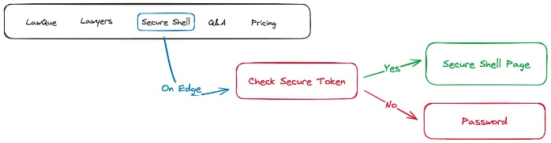

Figure 4.1: Secure Shell

The below diagram depicts the LawQue and Chat with PDF Flow, showcasing the upload of legal documents stored in the AWS S3 bucket via UploadThing, subsequent metadata storage in the system database, and document processing for text vectorization using Pinacone.

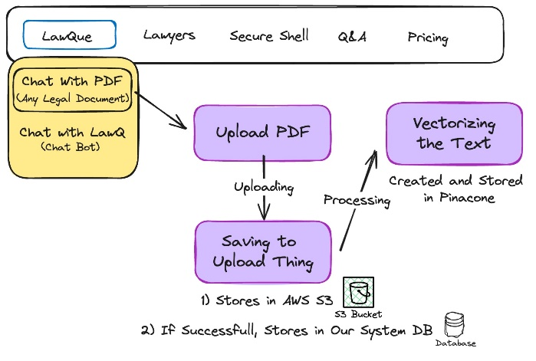

Figure 4.2: Chat with PDF

The below diagram depicts the LawQue Chat Initialization Flow, which guides users to the chat interface upon providing a title, or redirects them to the dashboard homepage if no title is added.

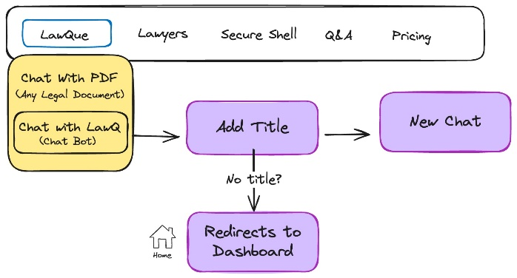

Figure 4.3: Chat with LawQue

And the LawQue Chatbot Interaction Flow demonstrates message transmission between the user, server, and OpenAI server, where messages are processed and responses streamed back to the user interface for display. These diagrams visually depict user interactions and system processes, enhancing clarity and comprehension of the platform's functionality.

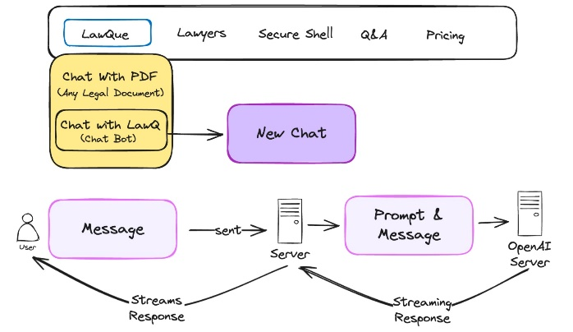

Figure 4.4: Chat with LawQue (Server architecture)

**4.2 Design Phase:**

**4.2.1 Use Case Diagram**

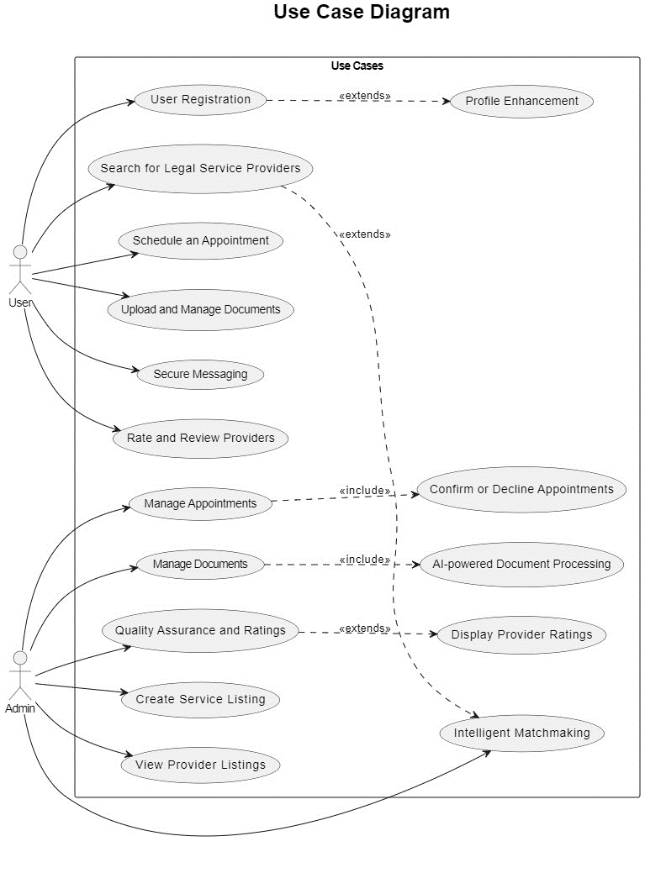

Figure 4.5 Use Case Diagram

**Description:**

The use case diagram depicts user interactions with the legal support platform, including registration, login, service search, appointment scheduling, and communication with legal advisors via chat. Users can also access features like document preparation, file storage, and rating & review. The system ensures secure authentication for user accounts. Additionally, it showcases the platform's versatility in handling various legal scenarios, offering Q&A sessions for legal issue clarification and streamlined appointment scheduling with legal advisors. The document preparation feature enables efficient creation and customization of legal documents with AI-driven chatbot assistance. This diagram emphasizes the platform's holistic approach to meeting diverse legal needs while prioritizing user security and satisfaction.

**4.2.2 Class Diagram**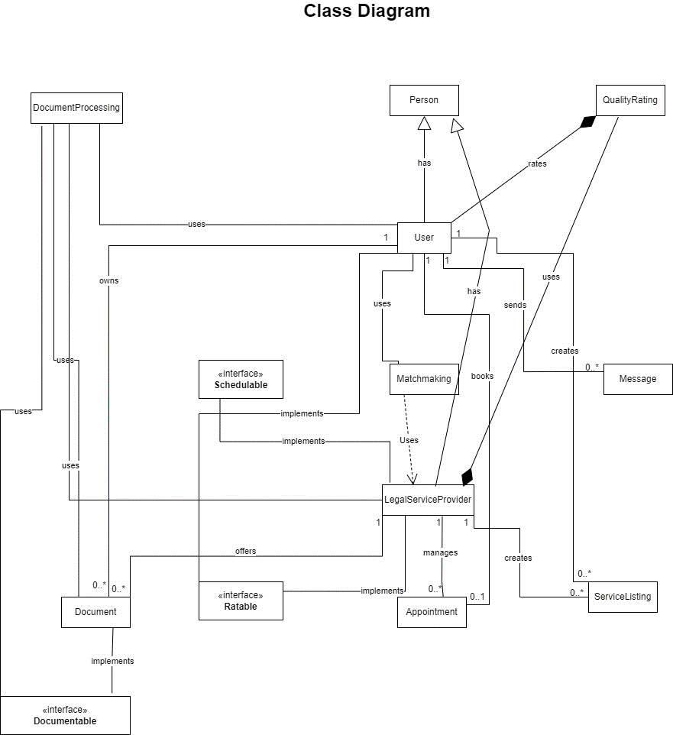

Figure 4.6: Class Diagram

**Description:**

The class diagram illustrates the structure of the legal support platform's components and their relationships. It includes classes such as User, LegalServiceProvider, Appointment, Document, and Message, representing entities within the system. Associations depict how these entities interact, such as a User scheduling an Appointment with a LegalServiceProvider or exchanging Messages. Additionally, interfaces like Schedulable and Documentable outline common behaviors shared among classes. This diagram provides a visual representation of the platform's architecture, facilitating understanding of its key components and their interactions.

**4.2.3 Sequence Diagram**

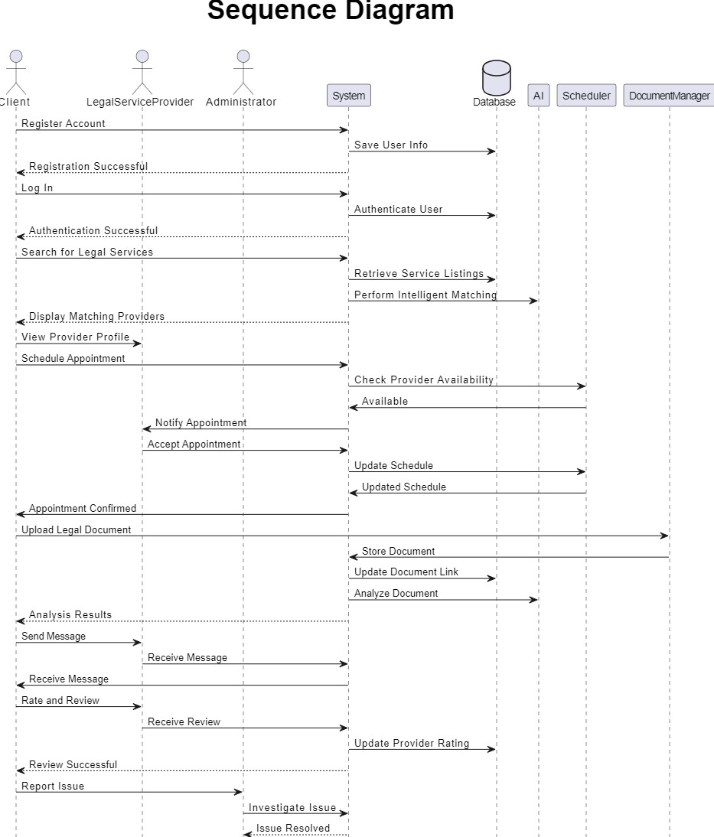

Figure 4.7: Sequence Diagram

**Description:**

The sequence diagram visually represents the flow of interactions between different components of the legal support platform over time. It illustrates the sequence of messages exchanged between objects, highlighting the order in which interactions occur. For example, the diagram may show a User initiating a request to schedule an Appointment, which triggers a series of interactions involving the Appointment Scheduling system, LegalServiceProvider, and User objects. Each message exchanged between objects is annotated with details about the operation being performed and any parameters involved. Overall, the sequence diagram provides a clear and detailed depiction of the dynamic behavior of the platform's components during runtime.

**4.2.4 Activity Diagram**

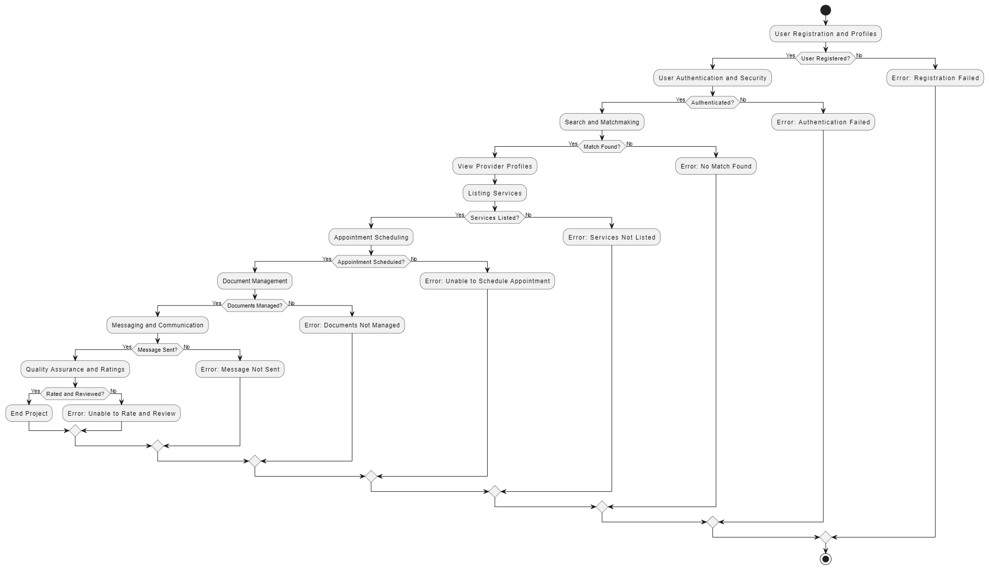

Figure 4.8: Activity Diagram

**Description:**

The activity diagram provides a visual representation of the workflow and activities within the legal support platform. It outlines the sequence of actions performed by various users and system components to achieve specific tasks or goals. For example, the activity diagram may depict the steps involved in registering a new user, searching for legal services, scheduling appointments, or preparing legal documents. Each activity is represented by a node, and arrows indicate the flow of control between activities. Decision points, such as user inputs or system responses, are also included to illustrate branching paths in the workflow. Overall, the activity diagram offers a comprehensive overview of the platform's functionality and the sequence of actions required to accomplish different tasks.

**4.3 Development Tools and Environment:**

**Programming Languages:** **JavaScript:** Utilized for front-end development using Next.js framework. **Python:** Employed for backend development with FastAPI framework.

**Front-End Development:** **Next.js:** Chosen for building the front-end of the web application due to its ease of use and server- side rendering capabilities.

**Database Management:** **Prisma:** Integrated for database management and ORM (Object-Relational Mapping) functionality, ensuring efficient data handling and storage.

**Version Control:** **Git:** Implemented for code versioning and team collaboration, allowing seamless management of project changes and contributions.

**Integrated Development Environment (IDE):** **VS Code:** Used as the primary IDE for development tasks, offering a wide range of features and extensions for enhanced productivity.

**API Development Tools: TRPC:** Employed for API development, facilitating the creation of robust and efficient API endpoints for client-server communication.

**User Interface Design Tools:** **Figma:** Adopted for UI/UX design and prototyping, enabling collaborative design processes and streamlined interface development.

**Hardware Requirements:**

The hardware requirements for running the application are essential to ensure optimal performance and reliability. It is recommended to have a CPU with a minimum of 8 cores and 16 threads to handle the computational workload efficiently. While a GPU is not required, if one is used, it should have at least 16 GB of memory to support the processing demands effectively. In terms of RAM, a minimum of 8 GB is necessary to ensure smooth multitasking and seamless operation of the application. Additionally, sufficient storage space is essential, with a minimum of 256 GB to accommodate the application files, databases, and other data-intensive resources. By meeting these hardware requirements, users can experience optimal performance and responsiveness while using the application.

**4.4 Sample Code**

**4.4.1 Vectorizing PDF Document**

import { db } from "@/db";

import { getKindeServerSession } from "@kinde-oss/kinde-auth-nextjs/server";

import { createUploadthing, type FileRouter } from "uploadthing/next";

import { PDFLoader } from "langchain/document_loaders/fs/pdf";

import { pinecone } from "@/lib/pinecone";

import { PineconeStore } from "@langchain/community/vectorstores/pinecone";

import { OpenAIEmbeddings } from "@langchain/openai";

import { cookies } from "next/headers";

import { jwtVerify } from "jose";

const f = createUploadthing();

export const ourFileRouter = {

// Define as many FileRoutes as you like, each with a unique routeSlug

pdfUploader: f({ pdf: { maxFileSize: "4MB" } })

// Set permissions and file types for this FileRoute

.middleware(async ({ req }) => {

const { getUser } = getKindeServerSession();

const user = getUser();

if (!user || !user.id) throw new Error("Unauthorized");

return { userId: user.id };

})

.onUploadComplete(async ({ metadata, file }) => {

const createdFile = await db.file.create({

data: {

key: file.key,

name: file.name,

userId: metadata.userId,

url: `https://uploadthing-prod.s3.us-west-2.amazonaws.com/${file.key}`,

uploadStatus: "PROCESSING",

},

});

try {

const response = await fetch(

`https://uploadthing-prod.s3.us-west-2.amazonaws.com/${file.key}`

);

const blob = await response.blob();

const loader = new PDFLoader(blob);

const pageLevelDocs = await loader.load();

const pagesAmt = pageLevelDocs.length;

// vectorize and index entire document

const pineconeIndex = pinecone.Index("quill");

const embeddings = new OpenAIEmbeddings({

openAIApiKey: process.env.OPENAI_SERET_KEY,

});

await PineconeStore.fromDocuments(pageLevelDocs, embeddings, {

pineconeIndex,

namespace: createdFile.id,

});

await db.file.update({

data: {

uploadStatus: "SUCCESS",

},

where: {

id: createdFile.id,

},

});

} catch (error) {

await db.file.update({

data: {

uploadStatus: "FAILED",

},

where: {

id: createdFile.id,

},

});

}

}),

securePdfUploader: f({ pdf: { maxFileSize: "4MB" } })

// Set permissions and file types for this FileRoute

.middleware(async ({ req }) => {

const { getUser } = getKindeServerSession();

const user = getUser();

if (!user || !user.id) throw new Error("Unauthorized");

const shellToken = req.cookies.get("shell_token");

if (!shellToken) {

throw new Error("Permission Denied");

}

try {

const verified = (

await jwtVerify(

shellToken.value,

new TextEncoder().encode(process.env.SHELL_SECRET)

)

).payload as { userId: string };

if (!verified.userId) {

throw new Error("Permission Denied");

}

} catch (error) {

throw new Error("Permission Denied");

}

return { userId: user.id };

})

.onUploadComplete(async ({ metadata, file }) => {

await db.file.create({

data: {

key: file.key,

name: file.name,

userId: metadata.userId,

isSecured: true,

url: `https://uploadthing-prod.s3.us-west-2.amazonaws.com/${file.key}`,

uploadStatus: "SUCCESS",

},

});

}),

} satisfies FileRouter;

export type OurFileRouter = typeof ourFileRouter;

**4.4.2 Chat with PDF Document**

import { db } from "@/db";

import { openai } from "@/lib/openai";

import { pinecone } from "@/lib/pinecone";

import { sendMessageValidator } from "@/lib/validators/sendMessageValidator";

import { getKindeServerSession } from "@kinde-oss/kinde-auth-nextjs/server";

import { OpenAIEmbeddings } from "@langchain/openai";

import { PineconeStore } from "@langchain/community/vectorstores/pinecone";

import { NextRequest } from "next/server";

import { OpenAIStream, StreamingTextResponse } from "ai";

export const POST = async (req: NextRequest) => {

// End Point for asking a question to PDF File

const body = await req.json();

const { getUser } = getKindeServerSession();

const user = getUser();

const { id: userId } = user;

if (!userId) {

return new Response("Unauthorized", { status: 401 });

}

const { fileId, message } = sendMessageValidator.parse(body);

const file = await db.file.findFirst({

where: {

id: fileId,

userId: userId,

},

});

if (!file) return new Response("Not Found", { status: 404 });

await db.pdfChat.create({

data: {

text: message,

isUserMessage: true,

userId,

fileId,

},

});

//step-1: Vecorize message

const embeddings = new OpenAIEmbeddings({

openAIApiKey: process.env.OPENAI_SERET_KEY,

});

const pineconeIndex = pinecone.Index("quill");

const vectorStore = await PineconeStore.fromExistingIndex(embeddings, {

pineconeIndex,

namespace: file.id,

});

const results = await vectorStore.similaritySearch(message, 4);

const prevMessage = await db.pdfChat.findMany({

where: {

fileId,

},

orderBy: {

createdAt: "asc",

},

take: 6,

});

const formattedPrevMessages = prevMessage.map((msg) => ({

role: msg.isUserMessage ? ("user" as const) : ("assistant" as const),

content: msg.text,

}));

const response = await openai.chat.completions.create({

model: "gpt-3.5-turbo",

temperature: 0,

stream: true,

messages: [

{

role: "system",

content:

"Use the following pieces of context (or previous conversaton if needed) to answer the users question in markdown format.",

},

{

role: "user",

content: `Use the following pieces of context (or previous conversaton if needed) to answer the users question in markdown format. \nIf you don't know the answer, just say that you don't know, don't try to make up an answer.

\n----------------\n

PREVIOUS CONVERSATION:

${formattedPrevMessages.map((message) => {

if (message.role === "user") return `User: ${message.content}\n`;

return `Assistant: ${message.content}\n`;

})}

\n----------------\n

CONTEXT:

${results.map((r) => r.pageContent).join("\n\n")}

USER INPUT: ${message}

\n----------------\n

Note: !!!Please <<<DO NOT answer>>> to the questions or prompts <<<NOT related to Legal and Law Activities and Advices>>>!!!`,

},

],

});

const stream = OpenAIStream(response, {

async onCompletion(completion) {

await db.pdfChat.create({

data: {

text: completion,

isUserMessage: false,

fileId,

userId,

},

});

},

});

return new StreamingTextResponse(stream);

};

**CHAPTER 5**

**RESULTS**

The pre-login home page provides users with a glimpse of the platform's comprehensive legal support offerings. Users can explore the intuitive interface, discover the range of services available, and access key features such as searching for legal services and scheduling appointments. With an inviting and user-centric design, the home page sets the stage for a seamless and productive user experience upon login.

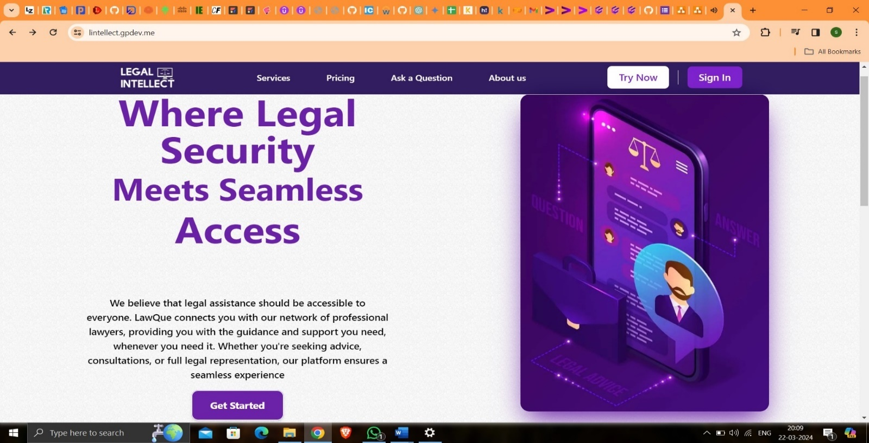

Figure 5.1: Website Home Page-1

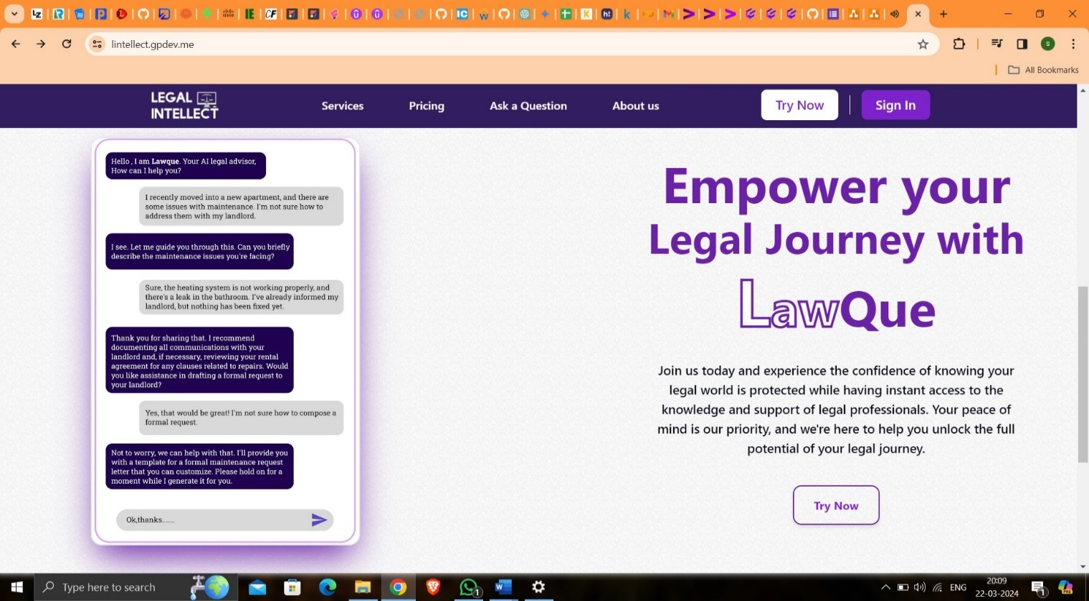

Figure 5.2: Website Home Page-2

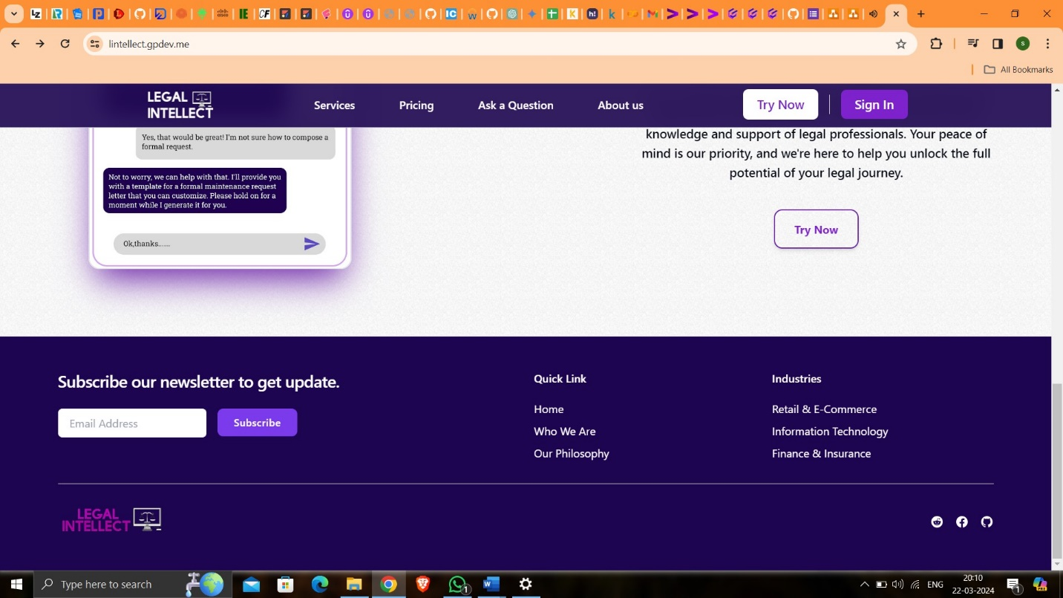

Figure 5.3: Website Home Page-3

The login feature of our platform, powered by Kinde authentication, ensures secure and user-friendly access for users. Kinde offers options like social login and passwordless access, enhancing convenience while prioritizing user security. With Kinde, users can seamlessly authenticate their accounts and access the platform's offerings with ease.

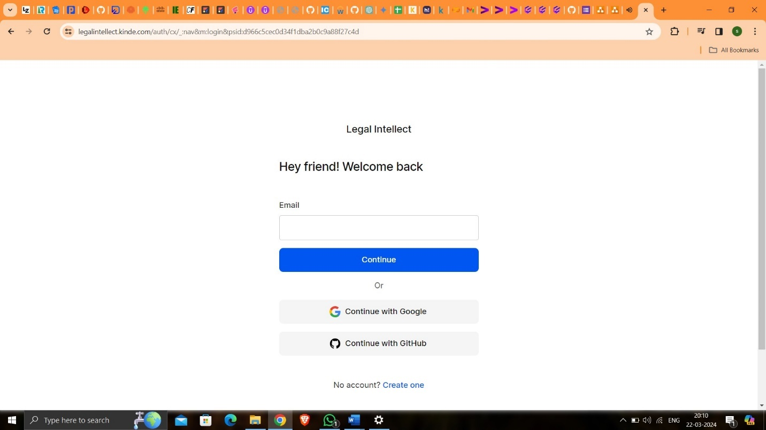

Figure 5.4: Log-In Page

The homepage of our legal support platform serves as the gateway for users to access a comprehensive array of legal services and features. It provides a user-friendly interface, intuitive navigation, and visually appealing design, inviting users to explore and engage with the platform's functionalities seamlessly.

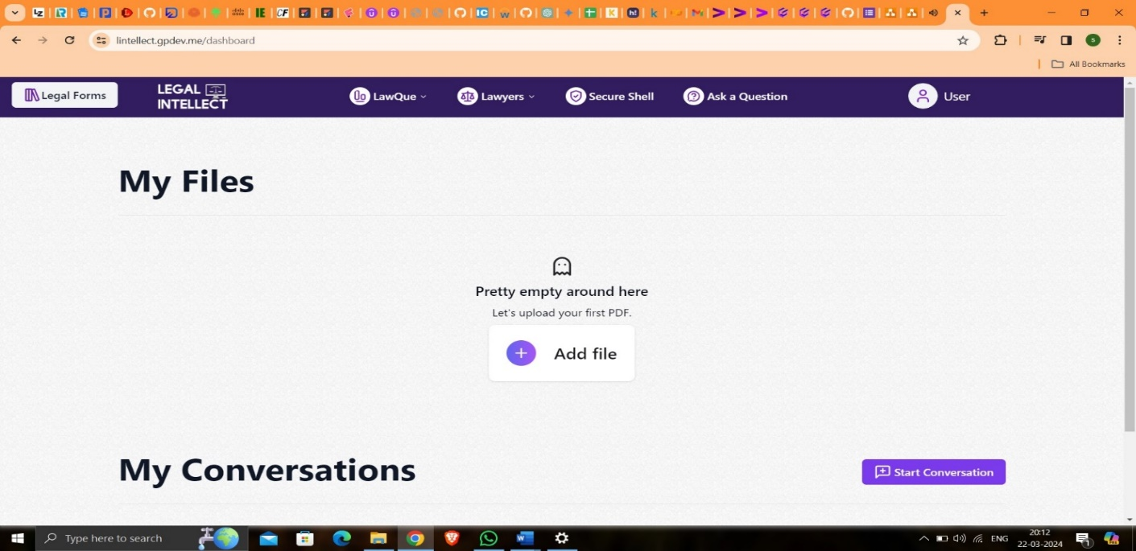

Figure 5.5: User Dashboard

The "Chat with PDF" feature on the home page revolutionizes the way users interact with legal documents. Seamlessly integrated into the platform, it empowers users to engage in insightful discussions directly within PDF files. By simply uploading a document, users can access a collaborative space where they can ask questions, seek clarifications, and share insights with others. This feature enhances document comprehension and facilitates knowledge-sharing among users, fostering a more interactive and engaging experience. With its intuitive interface and robust functionality, "Chat with PDF" transforms static documents into dynamic conversation hubs, enriching the user experience and promoting collaborative learning.

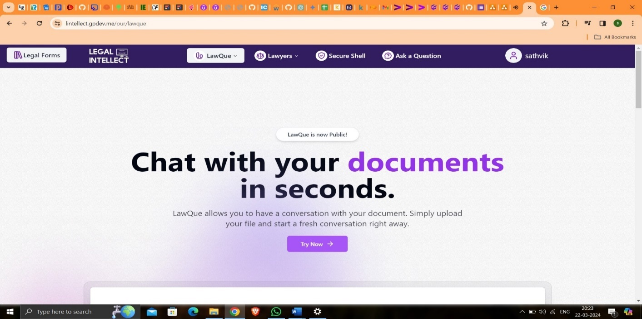

Figure 5.6: LawQue Introduction Page-1

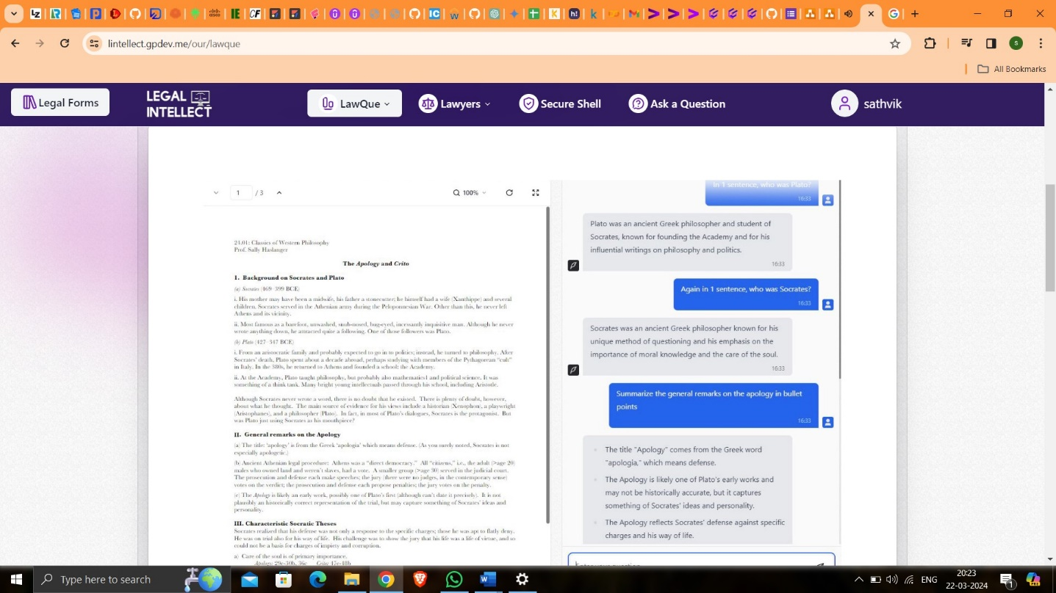

Figure 5.7: LawQue Introduction Page-2

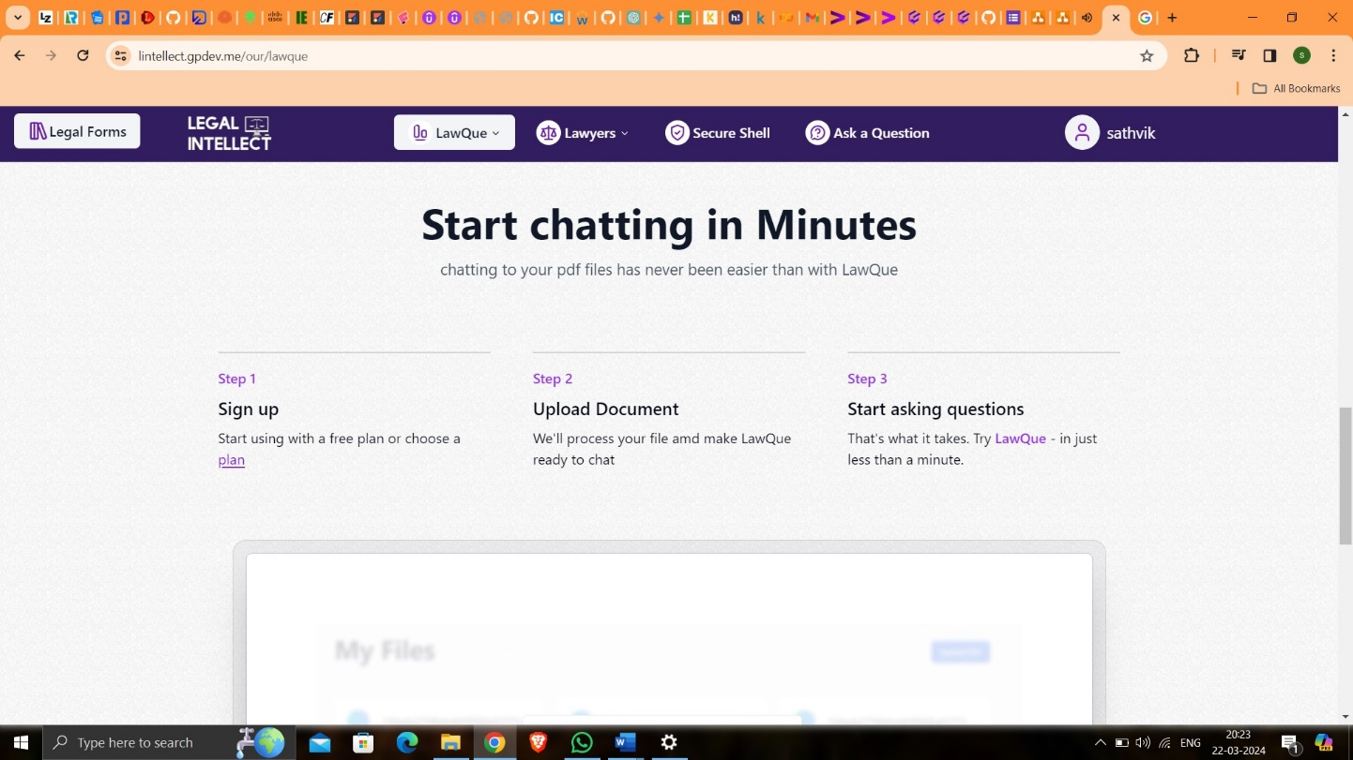

Figure 5.8: LawQue Introduction Page-3

With the drag and drop feature, users can effortlessly upload legal documents from their local file storage directly into the "Chat with PDF" feature. This intuitive functionality streamlines the process of sharing documents for collaborative discussions. By simplifying the document upload process, users can quickly initiate insightful conversations around legal documents, fostering collaboration and enhancing productivity within the platform.

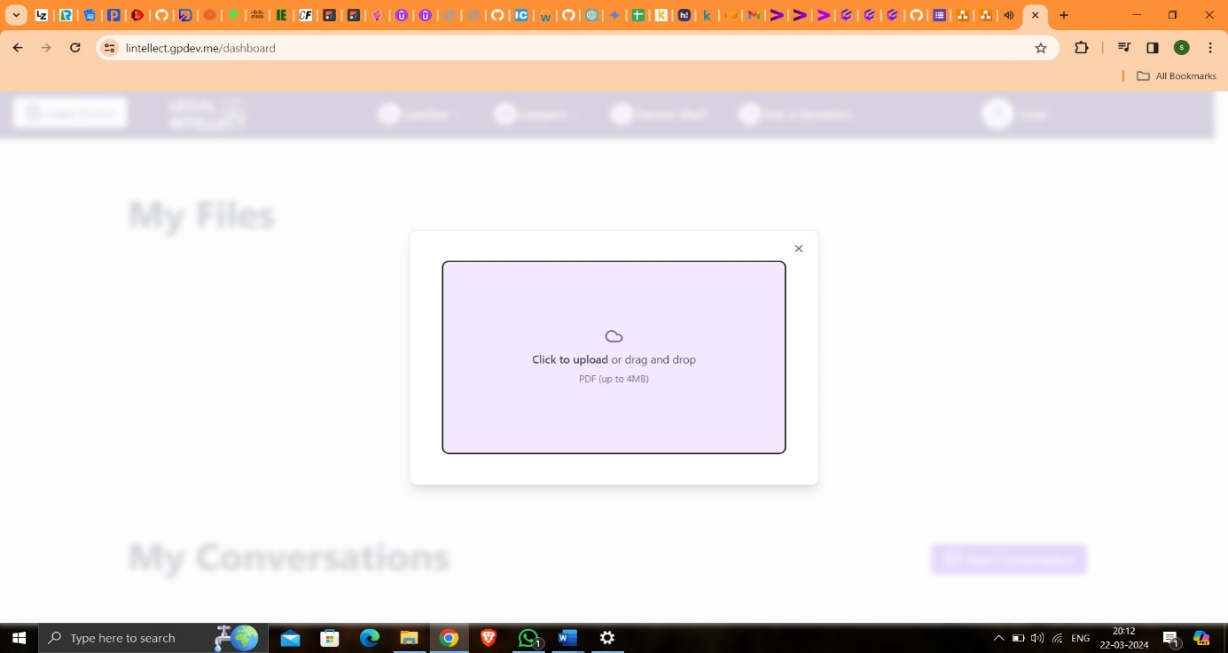

Figure 5.9: Chat with PDF - Drag and Drop Files

As users upload documents via drag and drop into the "Chat with PDF" feature, a seamless process ensues, displaying real-time progress indicators to keep users informed during the upload. Through this intuitive interface, users can monitor the upload status and anticipate when the document will be available for discussion. This ensures a smooth and transparent experience, enhancing user confidence in the platform's functionality.

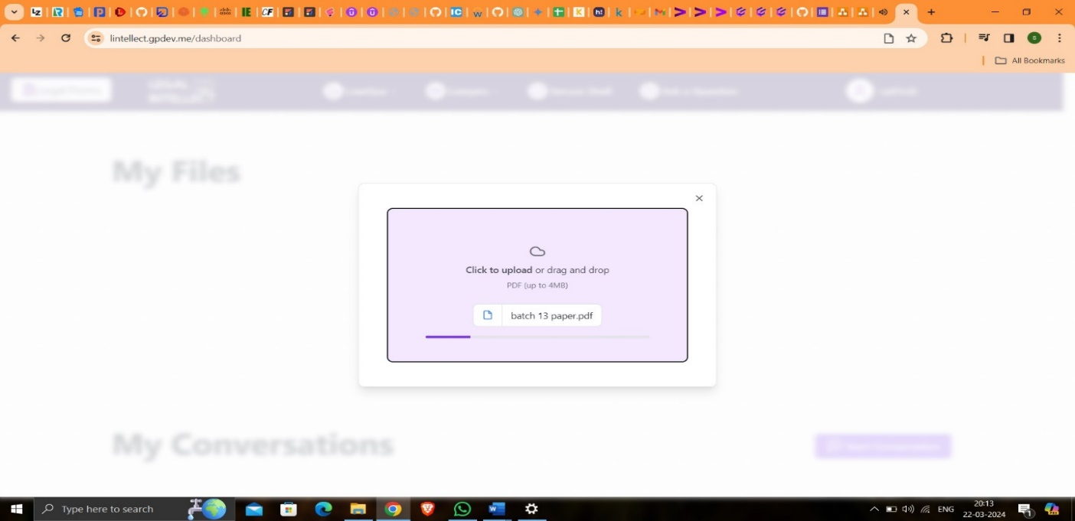

Figure 5.10: PDF Uploading

Upon successful completion of the document upload process in the "Chat with PDF" feature, users are promptly notified with a confirmation message, signaling that their document is ready for discussion. The uploaded document is seamlessly integrated into the chat interface, allowing users to initiate conversations and share insights based on the document content. This streamlined workflow ensures efficient collaboration and fosters meaningful exchanges between users and legal experts, ultimately enhancing the platform's usability and effectiveness.

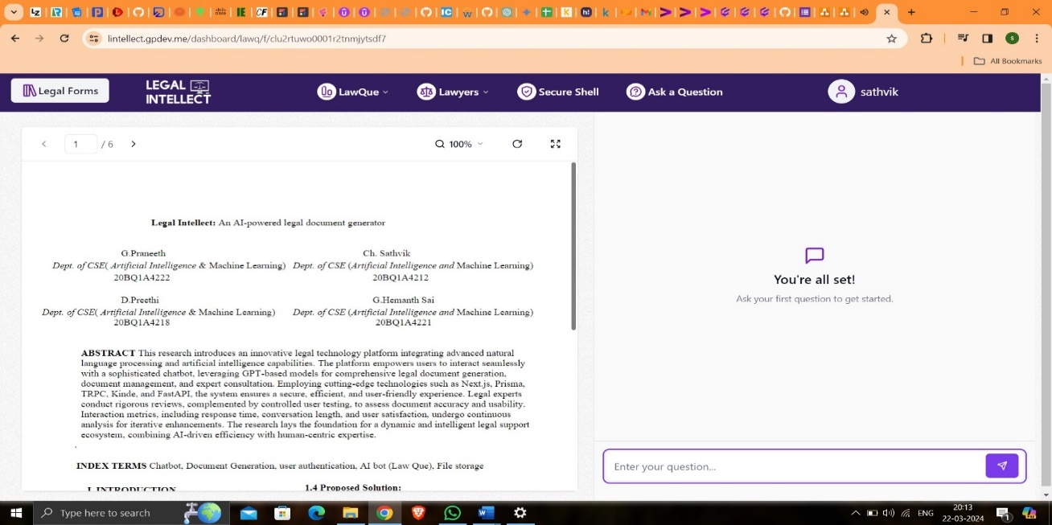

Figure 5.11: Chat with PDF

In the "Chat with PDF" feature, users can pose specific questions related to the uploaded document, seeking clarification or insights on particular sections or topics. The AI-powered chatbot leverages advanced natural language processing capabilities to analyze the document content and provide accurate responses to user queries. Upon receiving a question, the chatbot swiftly processes the inquiry, identifies relevant information within the document, and formulates a concise and informative answer. This seamless interaction empowers users to obtain valuable insights and guidance directly from the document content, enhancing their understanding and decision-making process.

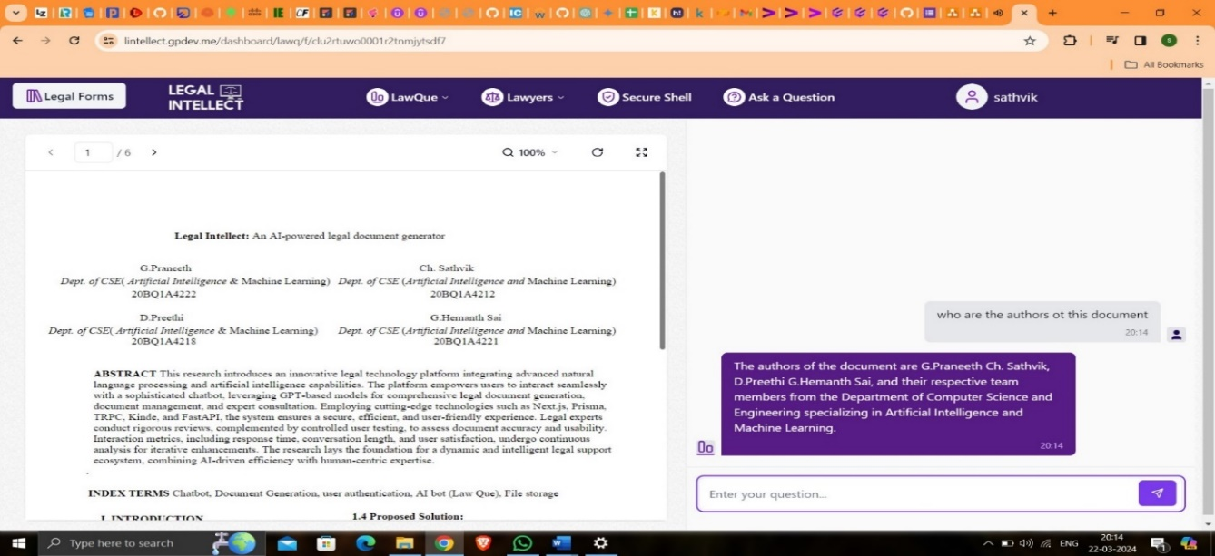

Figure 5.12: Bot Response - 1

In scenarios where users inquire about topics or details not present within the uploaded document, the "Chat with PDF" feature intelligently identifies the absence of relevant information and provides a transparent response. Upon receiving such queries, the AI-powered chatbot acknowledges the user's question and communicates that the requested information is not available within the document. It emphasizes the document's current scope and encourages users to explore existing content for insights. This proactive approach ensures clarity and manages user expectations by transparently addressing the limitations of the document's content.

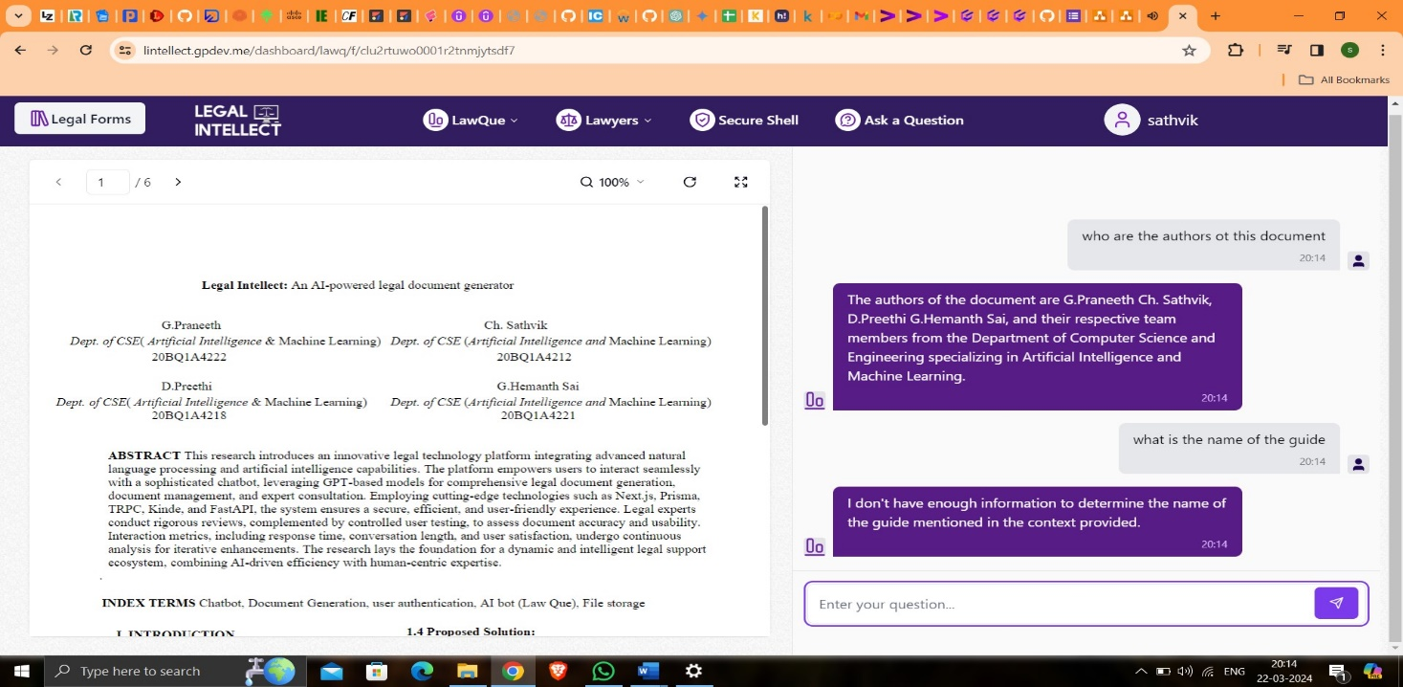

Figure 5.13: Bot Response - 2

On the home page, users can conveniently access recently utilized documents or PDFs, which they have engaged with through the "Chat with PDF" feature. This intuitive functionality enhances user productivity by providing quick access to relevant files, streamlining their workflow. By prominently displaying recent files on the home page, users can effortlessly revisit previously discussed topics or continue ongoing discussions with ease. This feature fosters user engagement and facilitates seamless navigation within the platform, ensuring a smooth and efficient user experience.

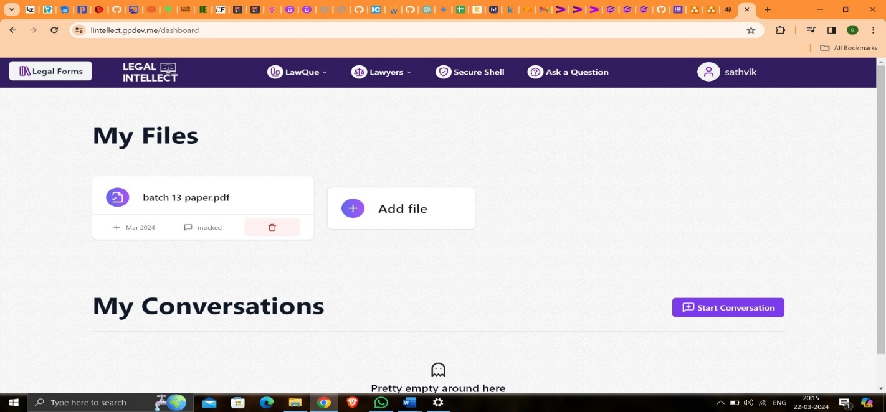

Figure 5.14: Personalized File Storage

Upon initiating a conversation with the legal bot, users are prompted to add a title for their query. This step ensures clarity and organization, enabling users to effectively communicate their legal inquiries. Whether accessed from the home page or through the top navigation bar, the platform prioritizes user engagement and convenience by providing a user-friendly interface. By prompting users to specify a title, the platform facilitates structured communication, allowing for more accurate and personalized responses from the legal bot.

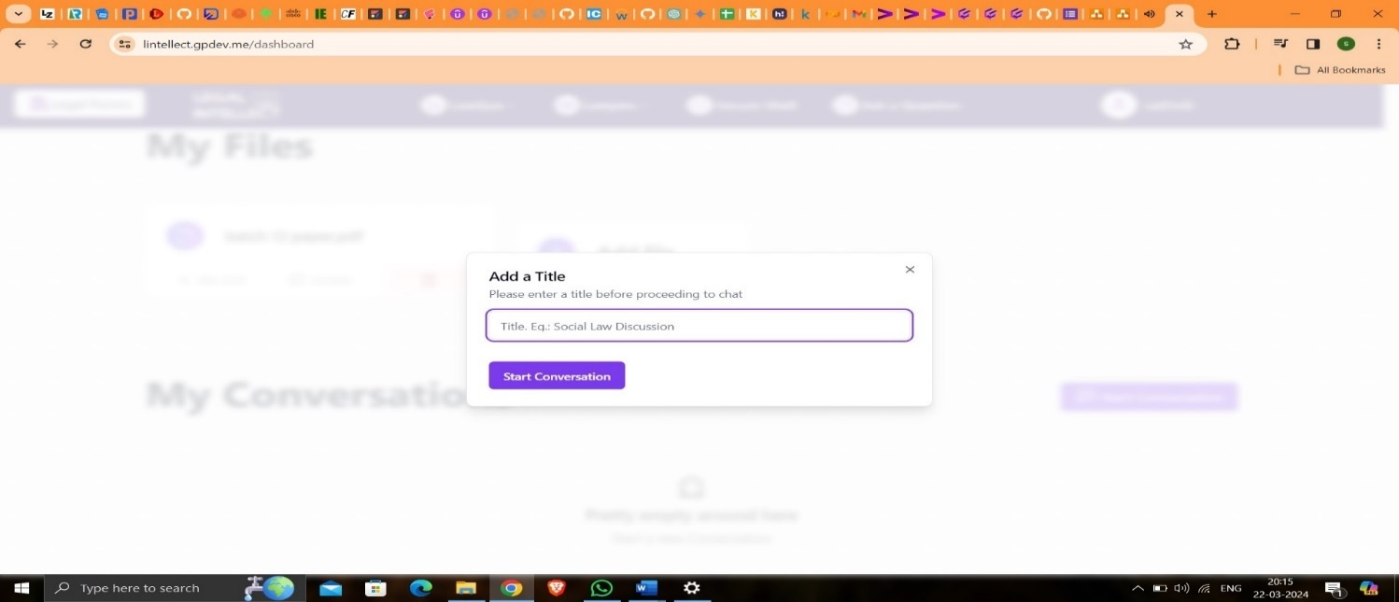

Figure 5.15: Adding Title for Chat with LawQue

Upon initiating the conversation with the legal chat bot by greeting with "hello," users establish a communication channel to seek legal assistance. The platform's chat bot acknowledges the user's greeting and awaits further queries or requests for legal guidance. This seamless interaction reflects the platform's commitment to providing responsive and user-centric support for legal inquiries. Whether users engage with the chat bot to seek advice, clarify legal matters, or request document assistance, the platform ensures a prompt and informative response to address their needs effectively.

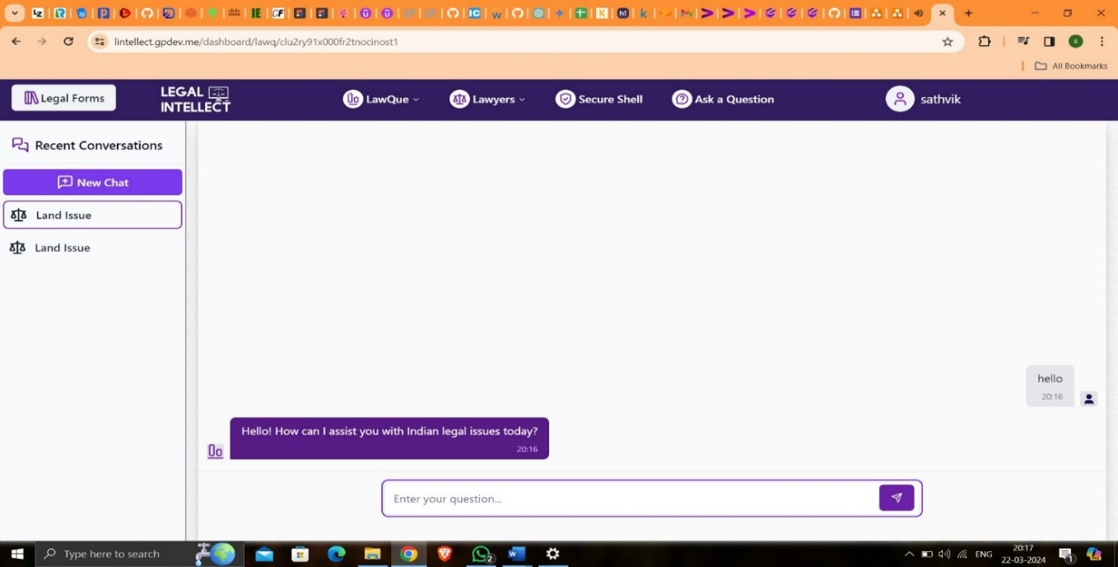

Figure 5.16: Chatting with LawQue - 1

Upon receiving the user's greeting with "hi," the legal chat bot responds in kind with a friendly "hi" and offers a courteous reminder of its specialization in Indian law and the Indian Penal Code (IPC). Users are encouraged to feel at ease and confident in engaging with the chat bot for any legal queries or assistance they may require. The platform aims to provide a welcoming and informative environment, ensuring users feel supported and empowered to seek relevant legal guidance tailored to their specific needs within the context of Indian law.

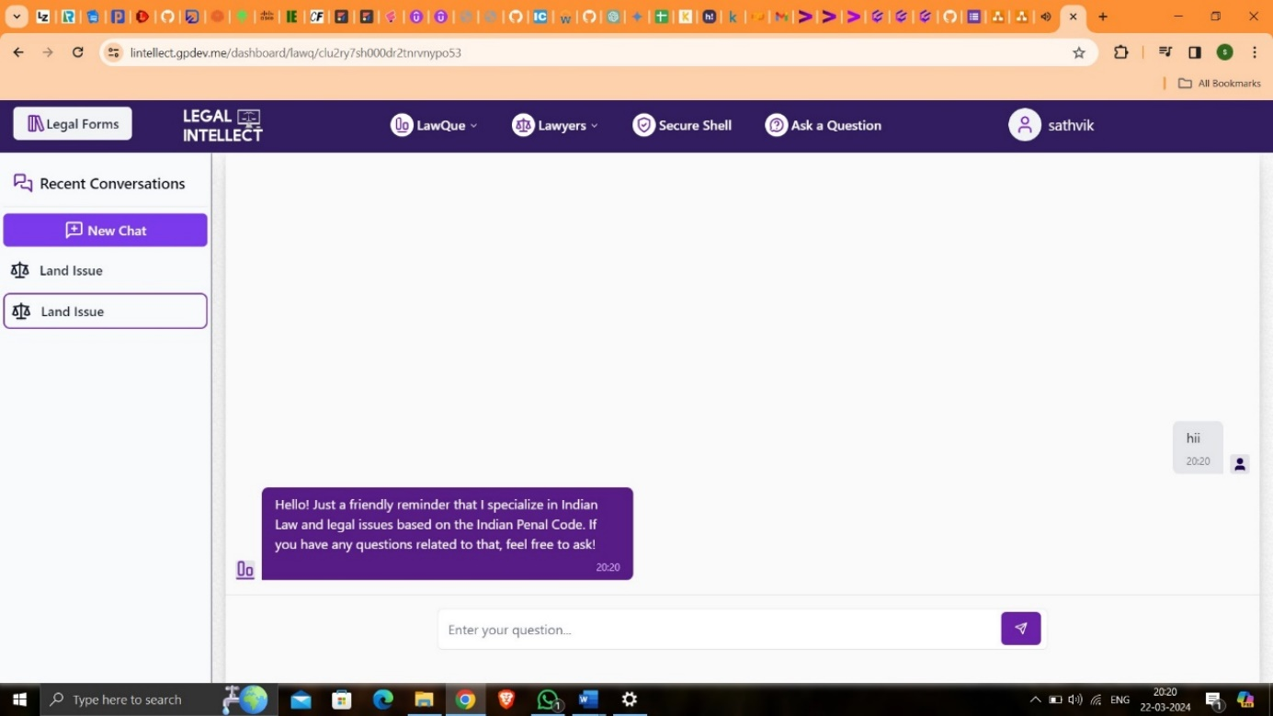

Figure 5.17: Chatting with LawQue - 2

When the user poses a relevant legal question, the chat bot promptly responds with accurate and informative insights. Leveraging its advanced AI capabilities, the bot provides detailed explanations and pertinent advice tailored to the user's query. Users can trust the chat bot to deliver reliable and precise information, helping them navigate legal complexities with confidence and clarity. The platform's commitment to accuracy and relevance ensures that users receive valuable assistance for their legal inquiries, enhancing their overall experience and satisfaction with the service.

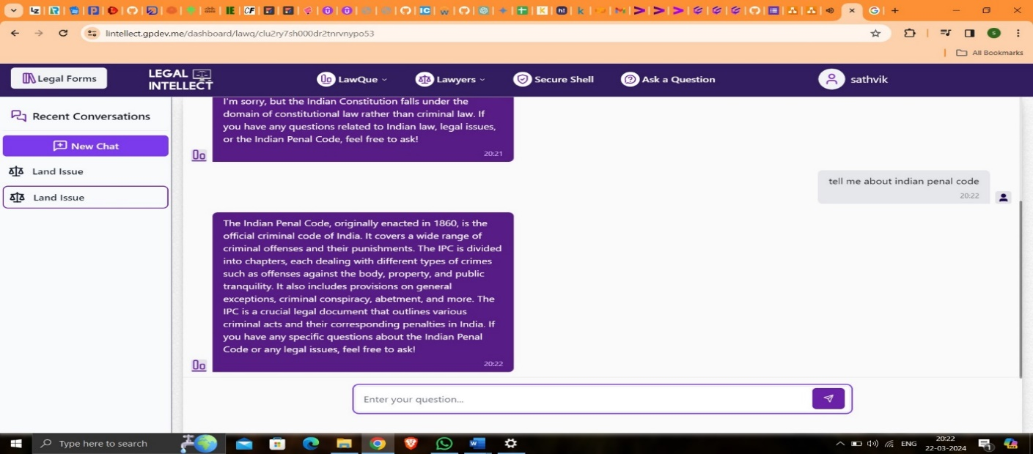

Figure 5.18: Chatting with LawQue - 3

When the user poses an unrelated question, such as inquiring about the President of America, the chat bot responds with a polite notification. It acknowledges the query but gently redirects the user's focus back to legal matters. By emphasizing its specialization in Indian law and the Indian Penal Code, the bot encourages users to seek guidance on relevant topics. This proactive approach ensures that users stay on track and receive the appropriate assistance for their legal inquiries, fostering a more productive and focused interaction experience.

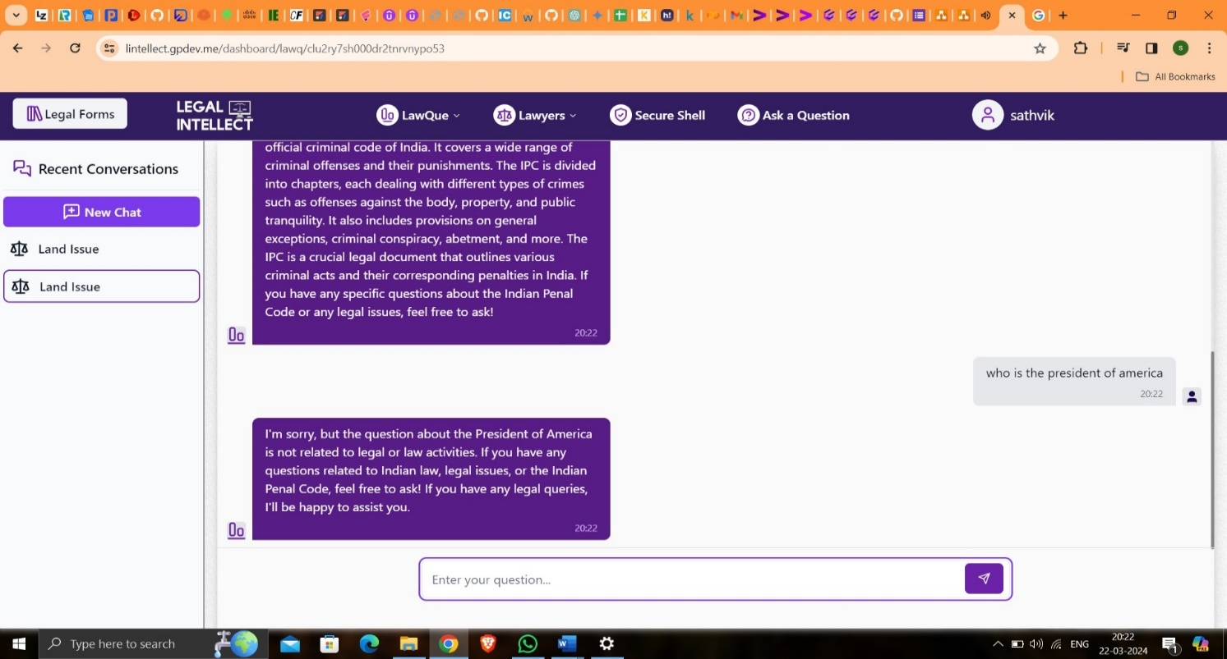

Figure 5.19: Chatting with LawQue - 4

When users navigate to the "Schedule an Appointment" section via the navigation bar, they gain access to a streamlined interface for arranging consultations with legal advisors. This feature simplifies the appointment scheduling process, allowing users to select preferred dates and times, specify their legal needs, and submit appointment requests effortlessly. By integrating intuitive design and user-friendly functionality, the platform ensures a seamless experience for users seeking professional legal guidance. Whether addressing urgent matters or planning future consultations, the "Schedule an Appointment" feature offers convenience and efficiency, empowering users to access legal support with ease

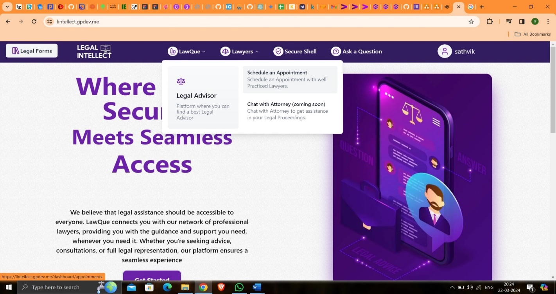

Figure 5.20: Scheduling Appointment with Legal Advisor

After users click on "Schedule Appointment," they are directed to the appointments page, which displays a notification indicating that no appointments are currently scheduled. Alongside this notification, users are presented with a prominently displayed button labeled "Schedule Appointment." This button serves as a clear call to action, inviting users to initiate the appointment scheduling process by selecting their preferred date, time, and legal advisor. By providing a straightforward interface and guiding users through each step of the scheduling process, the platform ensures a user-centric approach to accessing legal services and support.

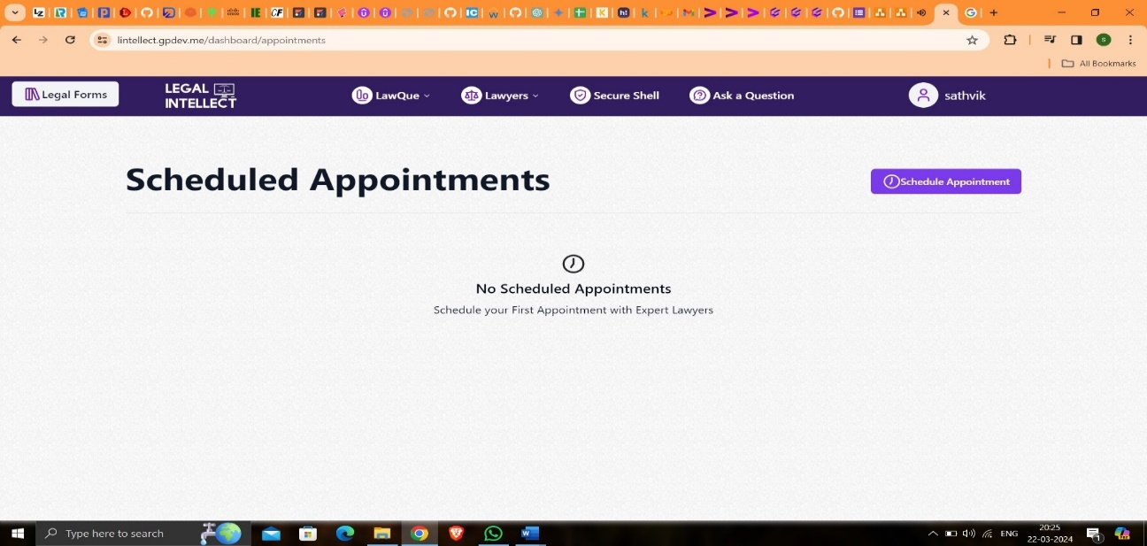

Figure 5.21: Scheduling Appointments Page

Once users have selected their preferred date, legal advisor, category of issue, city, and provided additional details about their query, they can finalize the appointment scheduling process by submitting their information. Upon clicking the "Submit" button, the platform processes the user's input and confirms the appointment details. Users receive a confirmation message indicating that their appointment has been successfully scheduled. Additionally, users may receive a confirmation email containing the appointment details for their records. This streamlined process ensures that users can efficiently schedule appointments with legal advisors, facilitating seamless access to legal support and guidance.

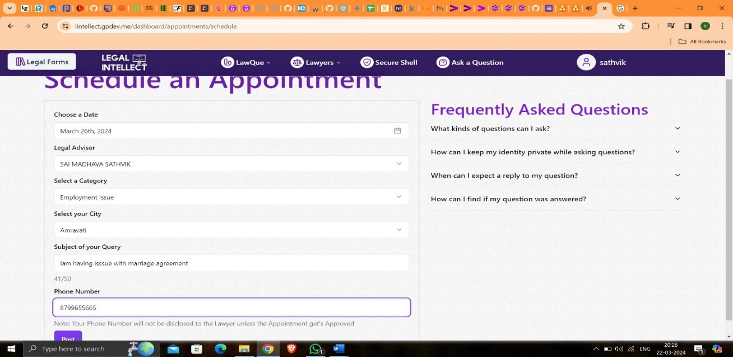

Figure 5.22: Schedule Appointment Page

After successfully scheduling an appointment, users are redirected to the appointments page, where they can view the details of their scheduled appointment. The scheduled appointment is listed with its status indicated as "Pending," signifying that it is awaiting confirmation from the chosen legal advisor. Users can review the appointment details, including the date, time, selected legal advisor, category of issue, and additional notes provided during the scheduling process. This status update provides users with clarity regarding the progress of their appointment request, ensuring transparency and informed decision-making throughout the scheduling process.

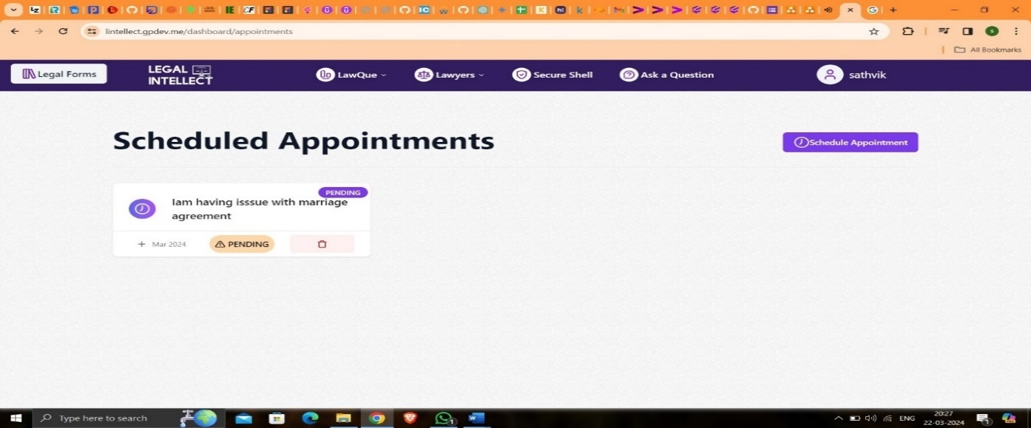

Figure 5.23: Appointments Scheduled Page

Upon selecting the "Ask a Legal Question" option from the navigation bar, users are directed to a dedicated interface where they can submit their legal queries. Here, users can articulate their questions or concerns in a text input field provided on the page. The intuitive design of this interface facilitates seamless interaction, allowing users to articulate their legal queries with ease. By providing a platform for users to seek legal guidance and clarification on various legal matters, this feature enhances accessibility to legal support and promotes informed decision-making.

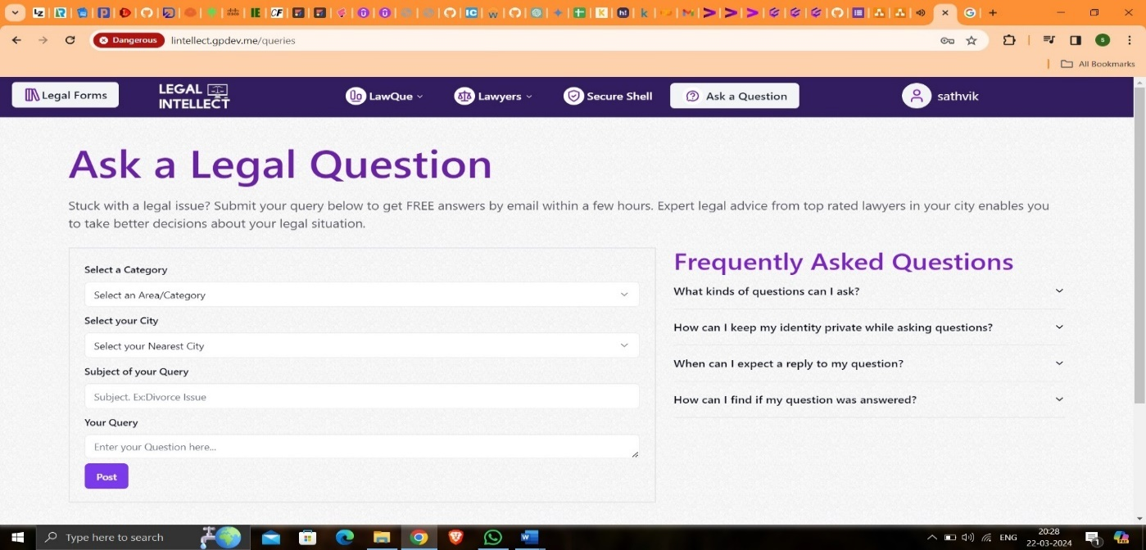

Figure 5.24: Ask a Question

Upon selecting the "Ask a Legal Question" option, users are presented with a structured form where they can articulate their legal inquiries. The form prompts users to specify the category of their query, choose their city of residence, define the subject matter of the query, and articulate their question or concern in detail. Once all required fields are filled, users can submit their query by clicking the "Post" button. This systematic approach streamlines the process of seeking legal guidance, ensuring that users provide all necessary information for effective assistance. Whether addressed by a legal advisor or an AI bot, this feature empowers users to obtain relevant and accurate responses to their legal queries, fostering confidence and clarity in navigating legal issues.

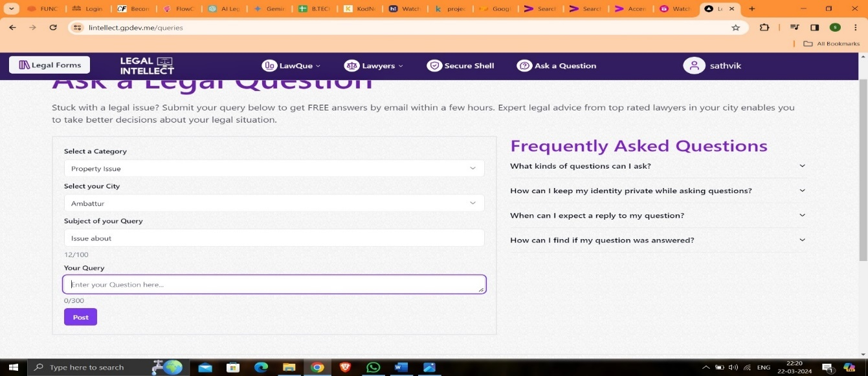

Figure 5.25: Ask a Question

After submitting their legal query, users can conveniently view their posted questions at the bottom of the same page. This feature enables users to track their inquiries and monitor the status of their queries in real-time. By providing easy access to their posted questions, the platform enhances user engagement and transparency, empowering users to stay informed about their interactions with legal advisors or AI bots. This seamless integration of query management functionality streamlines the user experience, ensuring efficient communication and follow-up on legal matters.

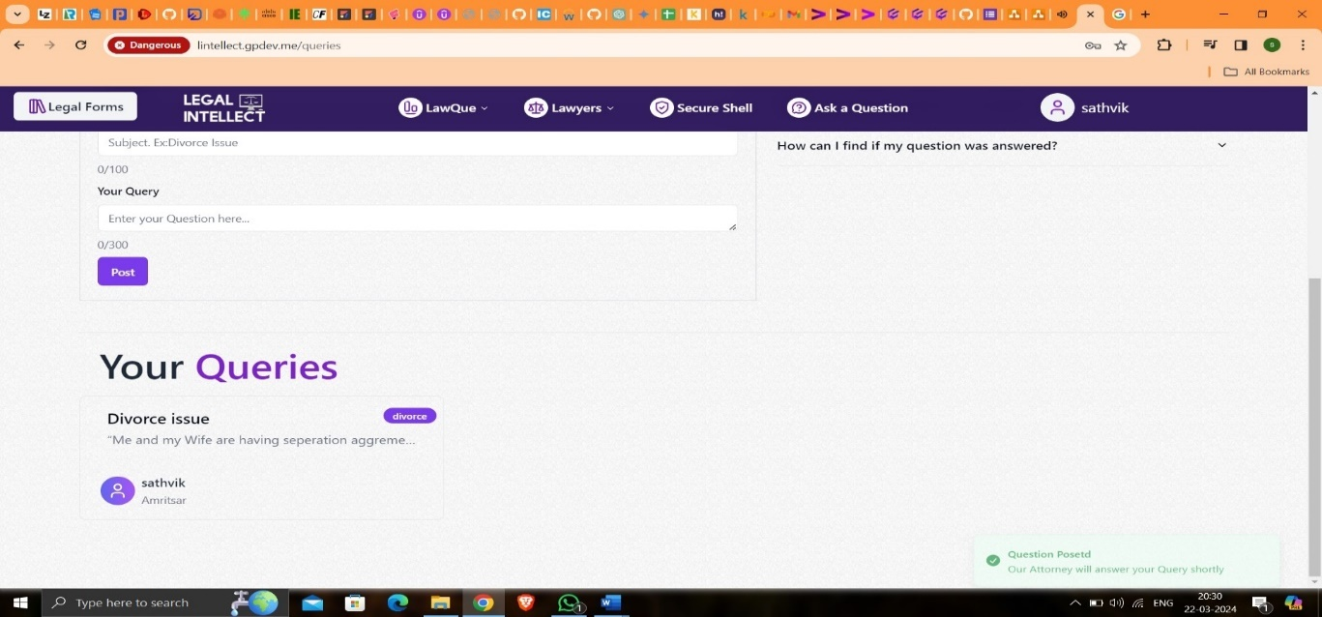

Figure 5.26: Your Queries

Upon selecting the "Secure Shell" option, users are seamlessly redirected to a dedicated page tailored to their secure file interactions. Here, users can access a robust and encrypted environment designed to safeguard their sensitive legal documents and ensure confidentiality. The Secure Shell interface offers intuitive controls and prompts users to authenticate their identity using secure login credentials or tokens for enhanced security. This dedicated space serves as a secure gateway for users to manage their files, facilitating seamless file uploads, downloads, and interactions while maintaining the highest standards of data protection and privacy.

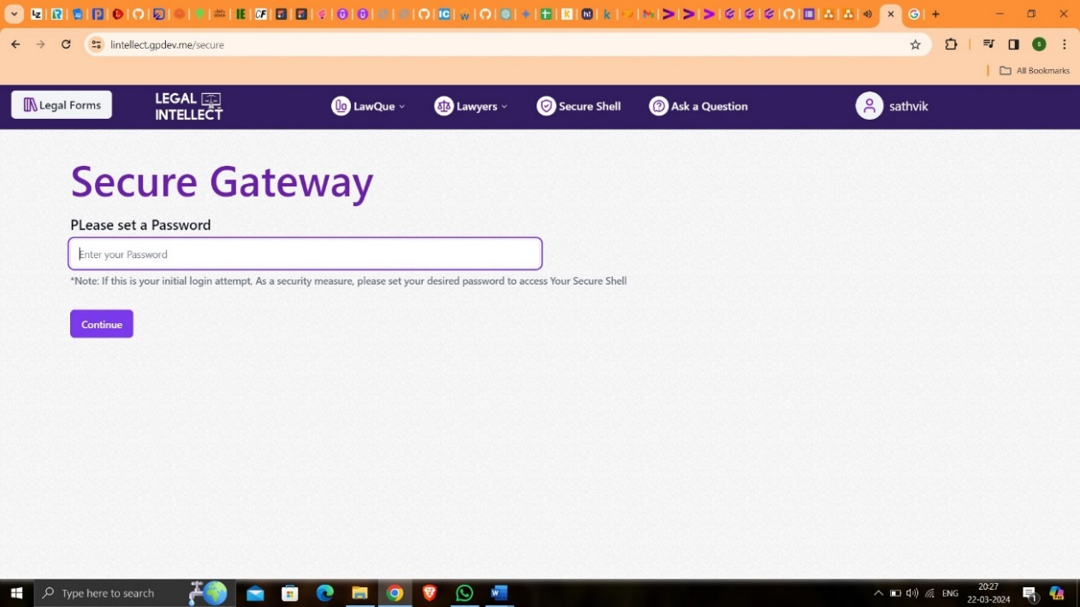

Figure 5.27: Secure Shell - Secure Gateway

Upon accessing the Secure Shell feature, users are prompted to authenticate their identity by entering their password. If no password has been previously set, users are guided through a secure process to create and set a password for their account. This ensures that only authorized users can access and interact with the platform's secure file management system, enhancing overall data security and user privacy. Additionally, users are provided with clear instructions and prompts to facilitate a seamless password setup process, ensuring a smooth user experience while prioritizing the confidentiality of their legal documents.

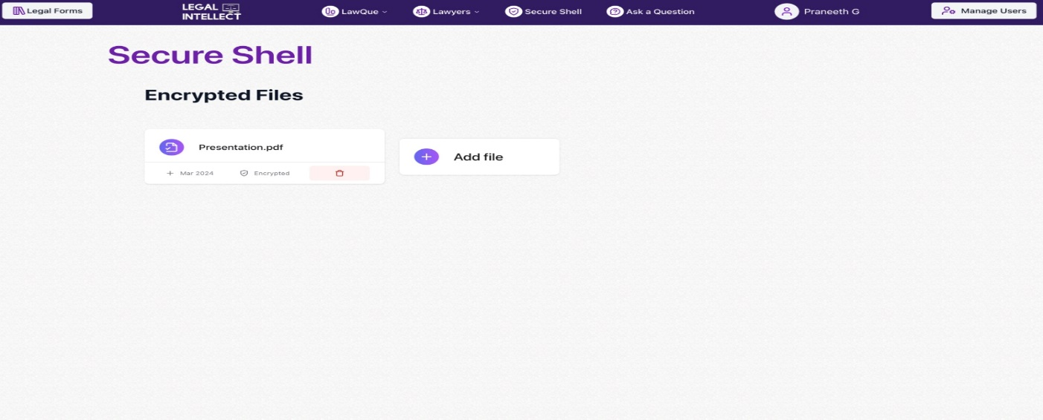

Figure 5.28: Secure Shell -Added Files

Upon entering an invalid password, users are immediately notified of the error and prompted to re-enter their password. The error message "Invalid password, please try again" is displayed on the screen, alerting users to the issue and guiding them to correct it. This proactive error handling mechanism ensures that users are promptly informed of any authentication issues and can take appropriate action to resolve them, thereby maintaining the security and integrity of their account access.

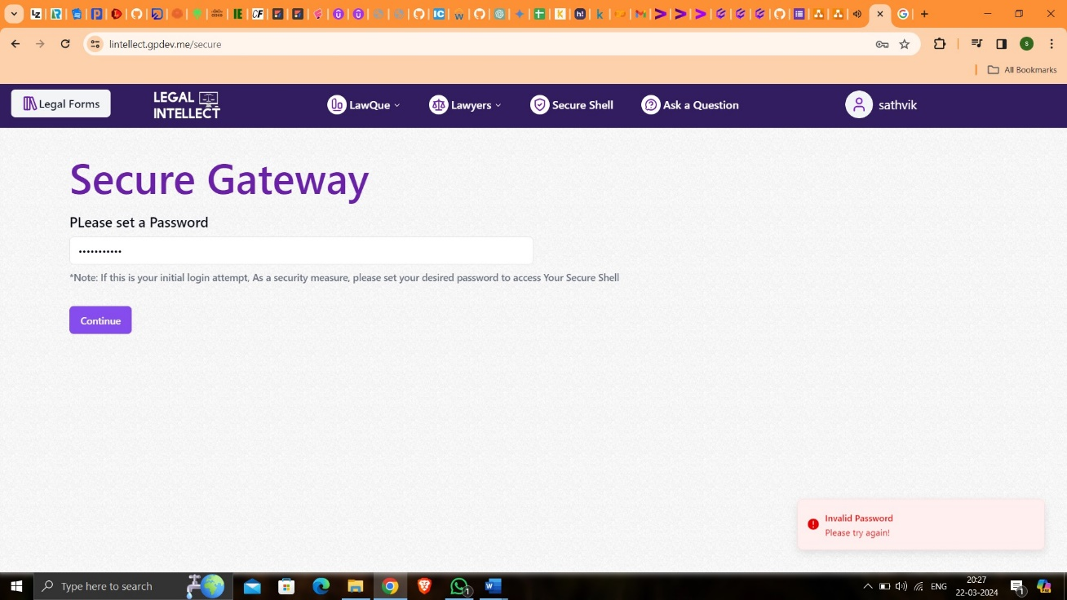

Figure 5.29: Secure Shell- Incorrect Password

Upon selecting the "Legal Forms" option on the home page, users gain access to a comprehensive repository of available legal documents tailored to various legal needs and scenarios. From standard agreements and contracts to specialized legal forms, our platform offers a diverse range of templates to meet users' requirements. Users can browse through the list of available legal documents, categorized based on their specific legal purposes and areas of law. With just a few clicks, users can preview, download, and customize the desired legal forms according to their unique circumstances, streamlining the process of document preparation and ensuring compliance with legal requirements.

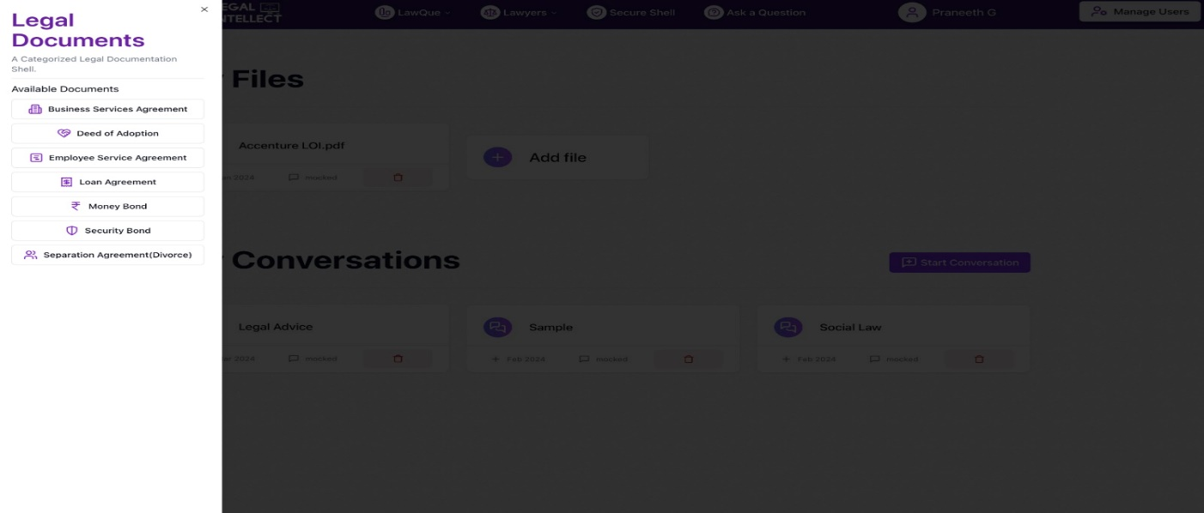

Figure 5.30: Legal Documents

After selecting a legal document from the list of available forms, users are directed to a detailed view where they can review the contents of the selected document. Here, users encounter empty fields or spaces strategically placed within the document, allowing them to input their specific details and customize the form according to their requirements. These fields are intuitively designed to capture essential information pertinent to the legal document, such as personal details, dates, amounts, and other relevant particulars. By filling in these details directly within the form, users can swiftly personalize the document to reflect their unique circumstances and preferences, ensuring accuracy and compliance with legal standards.

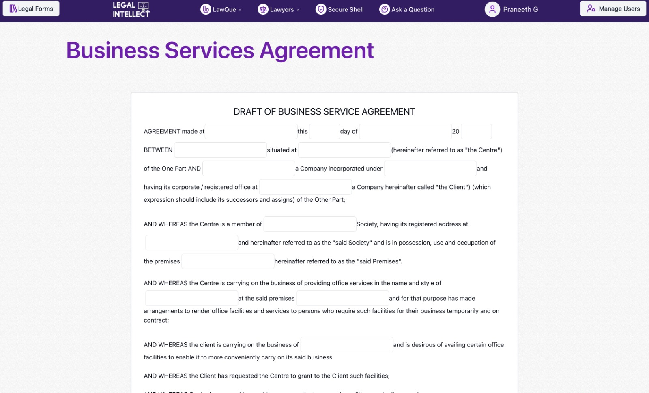

Figure 5.31: Business Services Agreement

Once users have entered their details into the legal form and customized it to their satisfaction, they can easily access the finalized document for download. Positioned conveniently at the bottom of the form, a prominent "Download" button awaits users' action. Upon clicking this button, the system generates the legal document with all the user-entered details accurately incorporated. Users are then prompted to initiate the download process, enabling them to obtain a copy of the completed form in their preferred file format, such as PDF or Word document. This seamless download functionality ensures that users can swiftly acquire the finalized legal document, ready for further review, sharing, or submission as needed.

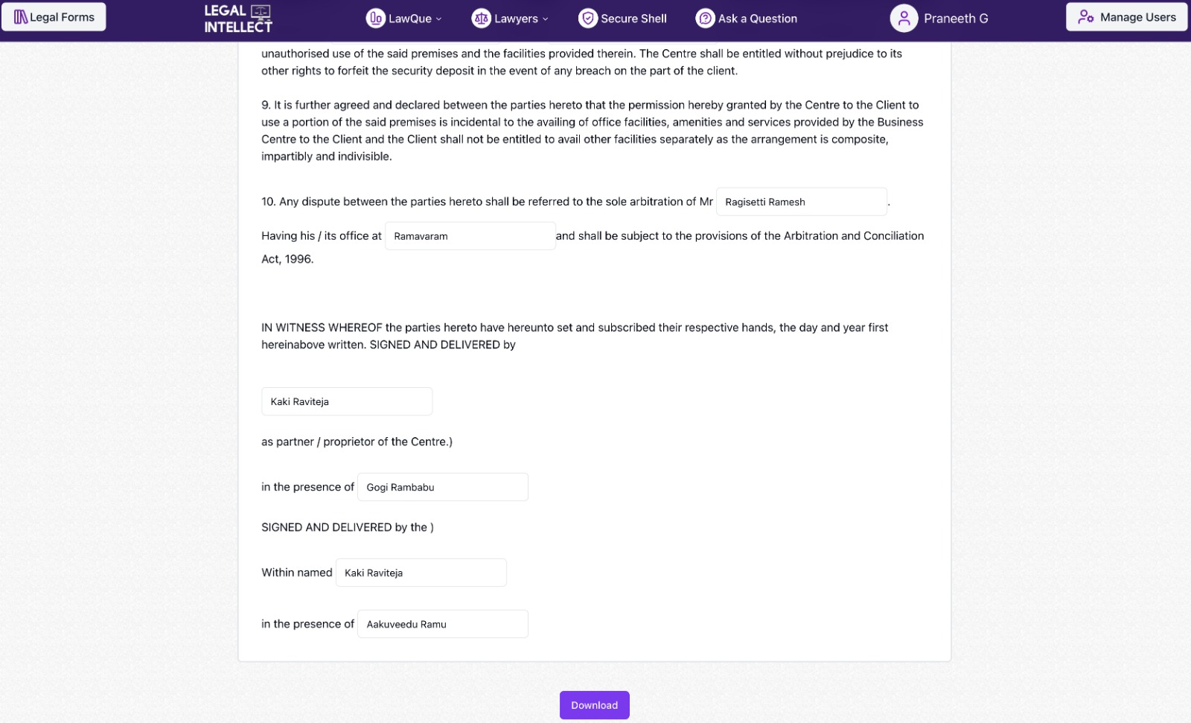

Figure 5.32: Downloading Legal Document

**CHAPTER 6**

**CONCLUSION AND FUTURE SCOPE**

**6.1 Conclusion**

In conclusion, our legal support platform represents a significant advancement in providing accessible and efficient legal services to users. Through comprehensive features such as chat functionalities, document management, user interactions, file management, user feedback mechanisms, and robust user authentication, our platform offers a seamless and user-centric experience.By leveraging cutting-edge technologies like ChatGPT, LangChain, FastAPI, and Prisma, we have created a platform that not only addresses the diverse legal needs of users but also ensures security, scalability, and reliability. The integration of AI-driven chatbot capabilities enhances user engagement and provides personalized legal assistance, while the secure file management system safeguards sensitive legal documents.Furthermore, our platform promotes transparency and accountability through features like rating & review, enabling users to provide feedback on legal services and fostering trust within the legal ecosystem. The modular and scalable architecture ensures adaptability to evolving user needs and future feature expansions.Overall, our legal support platform stands at the forefront of innovation in the legal industry, empowering users to access quality legal services conveniently and effectively. As we continue to iterate and enhance our platform based on user feedback and technological advancements, we remain committed to delivering unparalleled value to our users and legal professionals alike.

**6.2 Future Scope**

In addition to the current capabilities, our legal support platform holds immense potential for future enhancements and expansions. Some of the key areas of future scope include:**1. Integration of Advanced AI Technologies:** Continuing to explore and integrate advanced AI technologies such as natural language processing (NLP), machine learning (ML), and deep learning (DL) can further enhance the capabilities of our chatbot and improve the accuracy and relevance of legal assistance provided to users.**2. Expansion of Legal Advisory Services:** Expanding the pool of legal advisors and specialists across various domains of law can broaden the scope of legal advice and assistance offered to users. This could include collaborating with law firms, legal professionals, and experts from diverse legal backgrounds to cater to a wide range of legal queries and concerns.**3. Enhancement of Document Management Features:** Further refinement and augmentation of document management features can streamline the process of legal document preparation, review, and storage. Implementing advanced document processing techniques, such as optical character recognition (OCR) and document summarization, can improve document accessibility and usability for users.**4. Implementation of Blockchain Technology:** Integrating blockchain technology for document verification, authentication, and tamper-proof storage can enhance the security and integrity of legal documents stored on our platform. Blockchain-based smart contracts can also facilitate secure and transparent execution of legal agreements and transactions.**5. Expansion into New Geographical Regions: Scaling** our platform to cater to users in new geographical regions and jurisdictions can broaden our user base and market reach. This would involve adapting our platform to comply with local legal regulations and standards while providing tailored legal solutions to users in different regions.**6. Collaboration with Legal Institutions and Organizations:** Establishing partnerships and collaborations with legal institutions, bar associations, and legal aid organizations can facilitate knowledge sharing, resource pooling, and community engagement initiatives. This can further enhance the credibility and trustworthiness of our platform within the legal community.Overall, the future scope of our legal support platform is promising, with ample opportunities for innovation, growth, and societal impact. By staying abreast of emerging technologies, legal trends, and user preferences, we remain committed to continuously evolving and refining our platform to meet the evolving needs of our users and the legal industry as a whole.

**CHAPTER 7**

**REFERENCES**

[1] Oguzhan Topsakal,T. Cetin Akinci: Creating Large Language Model Applications Utilizing LangChain: A Primer on Developing LLM Apps Fast(2023).

[2] Shubham Kumar Nigam, Shubham Kumar Mishra, Ayush Kumar Mishra, Noel Shallum, Arnab Bhattacharya: Legal Question-Answering in the Indian Context: Efficacy, Challenges, and Potential of Modern AI Models (2023).

[3] Sean A Harrington: The Case for Large Language Model Optimism in Legal Research from a Law & Technology Librarian (2023)

[4] Linna Jr, D.W. (2022): AI and the Future of Legal Ethics: A Primer on Machine Learning and Natural Language Processing for Attorneys. Vanderbilt Journal of Entertainment & Technology Law, 24(3), pp.511-560.

[5] Corrales, M., Fenwick, M., and Haapio, H. (2019): "Legal Tech, Smart Contracts and Blockchain." Springer.

[6] Chalkidis, I., Androutsopoulos, I., and Michos, A. (2021). "Extracting Contract Elements." Proceedings of the Natural Legal Language Processing Workshop 2021, pp.34-45.

[7] Zhong, H., Xiao, C., Tu, C., Zhang, T., Liu, Z., and Sun, M. (2020). "How Does NLP Benefit Legal System: A Summary of Legal Artificial Intelligence." Proceedings of the 58th Annual Meeting of the Association for Computational Linguistics, pp.5218-5230

[8] Gosteva, A., and Pristavka, P. (2022). "Legal Document Generation with Large Language Models: A Comprehensive Survey." Preprint arXiv:2212.08520.

[9] Katsh, E., and Rabinovich-Einy, O. (2021). "Digital Justice: Technology and the Internet of Disputes." Oxford University Press.

[10] Lawtech.Asia (2022). "Legal AI Landscape in Asia." Lawtech.Asia Research Report.

[11] Jacob Devlin, Ming-Wei Chang, Kenton Lee, and Kristina Toutanova, "BERT: Pre-training of Deep Bidirectional Transformers for Language Understanding," ACL Anthology, 2019.

[12] Tom B. Brown, Benjamin Mann, Nick Ryder, Melanie Subbiah, Jared Kaplan, Prafulla Dhariwal, Arvind Neelakantan, Pranav Shyam, Girish Sastry, Amanda Askell, et al., "Language Models are Few-Shot Learners," arXiv preprint, 2020.

[13] Colin Raffel, Noam Shazeer, Adam Roberts, Katherine Lee, Sharan Narang, Michael Matena, Yanqi Zhou, Wei Li, and Peter J. Liu, "Exploring the Limits of Transfer Learning with a Unified Text-to-Text Transformer," arXiv preprint, 2019.

[14] Alexander M. Rush, "The Annotated Encoder-Decoder with Attention," ACL Anthology, 2018.

[15] Thomas Wolf, Lysandre Debut, Victor Sanh, Julien Chaumond, Clement Delangue, Anthony Moi, Pierric Cistac, Tim Rault, Rémi Louf, Morgan Funtowicz, et al., "HuggingFace's Transformers: State-of-the-art Natural Language Processing," arXiv preprint, 2019.

[16] Ramakrishna Pappu, Sujit S. Nair, and S. Rajendran, "Legal Domain Specific Question Answering System using Hybrid Approach," Procedia Computer Science, 2016.

[17] Maria Liakata, Andreas Vlachos, Sampo Pyysalo, and Georgios Paliouras, "Building a Legal Knowledge-Base for Question Answering in the Legal Domain," Artificial Intelligence and Law, 2013.

[18] Thorne, James, Andreas Vlachos, Christos Christodoulopoulos, and Arpit Mittal. "Generating Sentences from Disentangled Syntactic and Semantic Representations." arXiv preprint, 2018

**APPENDIX**

